Ch4. Articulatory Phonetics

The medium through which most of us experience language most of the time is sound: for all non-deaf language users, the first exposure to language is through sound, and in non-literate, hearing societies it is typically the only medium. Humans have a variety of ways of producing sounds, not all of which are relevant to language (for example coughing, burping, etc.). How sound is use language, that is, speech sounds, is the focus of this book, and one obvious place to start out is to look at the physical processes involved in the production of speech sounds by speakers — the study of articulatory phonetics.

This chapter examines (he major aspects of speech production:   
• the airstream mechanism — where the air used in speech starts from, and which direction it is travelling in.

• the state of the vocal cords — whether or not the vocal cords are vibrating, which determines voicing   
• the state of the velum — whether it is raised or lowered, which determines whether a sound is oral or nasal  
• the place and manner of articulation — the horizontal and vertical positions of the tongue and lips.

In Chapters 3 and 4 we look in some detail at different speech sounds. beginning with the various types of consonant and then moving on to vowels. The primary focus is on speech sounds found in different varieties of English. particularly Received Pronunciation CRP) and General American (GenAm). RP refers to a non-regional pronunciation found mainly in the United Kingdom, sometimes known non-technically as ‘BBC English’ or ‘the Queen's English’. General American refers to a standardized form of North American English. often associated with broadcast journalism and, thus, sometimes known as ‘network English’. Although the focus is on English, exemplification will also come from Other languages.

2.1 Overview

Speech sounds are created by modifying the volume and direction of a flow of air using various parts of the human respiratory system. We need to consider the state of these parts in Order to be able to describe and classify the sounds of human languages. Figure 2.1 illustrates the parts of anatomy we need to examine.

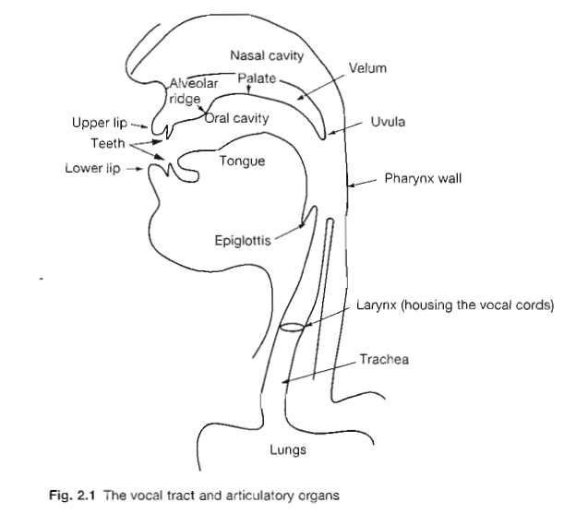

2.1. I Airstream mechanism

We can Start with the airflow itself — where is it initiated and which direction is it travelling in? The major 'initiator' is the lungs and the most common direction is for the air to flow out from the lungs through the trachea (windpipe), larynx (in the Adam's apple) and vocal tract (mouth and nose): all human languages involve this type of airstream mechanism, known as ‘pulmonic egressive' (= from the lungs outwards) and for many, including English, it is the sole airstream mechanism employed for speech sounds. A number of languages also employ other possibilities: the air may be moving inwards (an ingressive airstream mechanism), the flow itself may begin al the velum (soft palate) or the glottis (the space between the vocal cords) — velaric and glottalic airstreams respectively. This gives a possible six airstream mechanisms:

• pulmonic egressive — used in all human languages

• pulnlonic ingressive — not round

• velaric egressive — not found

• velaric ingressive — used in e.g. Zulu (S. Africa)

• glottalic egressive — used in e.g. Navajo (N. America)

• glottalic ingressive — used in e.g. Sindhi (India).

However, as can be seen from the list above, two of the possible types — pulmonic ingressive and velaric egressive — are not found in any human language (it is unclear why this is so).

Having established the starting point of the airflow and the direction it is travelling in, we can then look at what happens to it as it moves over the other organs involved in speech sound production. For what follows, we will assume a pulmonic egressive airstream mechanism; sounds produced with Other airstream types will be discussed in later sections.

2.1.2 The vocal cords

As air is pushed out from the lungs, it moves up the trachea into the larynx. In the larynx the airflow encounters the vocal cords. The vocal cords are actually two folds of tissue, but when visualized from above (as in laryngeal examination) they appear as white cords surrounded by pinkish areas (hence the popular term ‘vocal cords'). These flaps run from the arytenoid cartilages in the back to a point on the inner surface of the thyroid cartilage in the front. When the vocal cords are apart, as in Figure 2.2 (which shows an open glottis). then the air passes through unhindered. resulting in what is known as a voiceless sound.

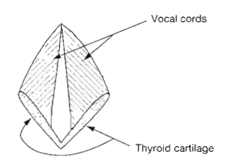

Fig. 2.2 open glottis

Note: In this and subsequent figures showing states of the glottis the bottom of the diagram corresponds to the front or the larynx. Note that all the figures in this chapter are schematic rather than anatomically accurate representations, such as in the initial and final sounds in the word 'pass’ (Since English orthography is not a system of phonetic representation, a single sound may be represented by more than one orthographic symbol. as in the final sound in ‘pass’.) Lying above the true vocal folds are the false folds. The false vocal folds can also be set into vibration to produce some sounds, such as with a cough, but are not normally associated with speech production. The thyroid cartilage, at the front of the larynx. causes the protrusion known as the Adam's apple in the front of the throat. If however the vocal cords are brought together by muscular contractions, as in Figure 2.3 (which shows a narrowed glottis), then as the air is forced through. air pressure causes the vocal cords to vibrate. This vibration (voicing) is maintained by aerodynamic and elastic forces until movement of the arytenoid cartilages separates the vocal cords. (This is a simplification of the complexities involved in the production of voicing; the reader interested in greater detail should consult one of the works listed in the Further Reading section at the end of this chapter.)

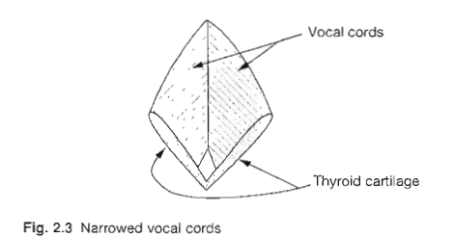

This vibration results in a voiced sound. as in all three sounds in ‘buzz'. You can feel (as well as hear) the difference between voiceless and voiced sounds by placing your finger against your Adam's apple and then making prolonged ‘sss' (as in ‘hiss') and ‘zzz' (as in ‘his') sounds: for the ‘zzz’ sound you should be able to feel the vibration of the narrowed vocal cords, while ‘sss' the vocal cords are wide apart and there is no such vibration. These two positions — open and narrowed — are the most common in the languages of the world, but the vocal cords may take on a number of other configurations which can be exploited by languages. For instance, they may be completely closed (see Figure 2.4). not allowing air to pass through at all and thus causing a build-up of pressure below the vocal cords: when they are opened. (he pressure is released with a forceful outrush of air (similar to a cough).

The sound so produced is known as a glottal stop which is found in many kinds of British English — e.g. Cockney, Glasgow, Manchester. etc. — as the final sound of words like ‘what’. Alternatively, the vocal cords may be open only at one end, as in Figure 2.5, resulting in what are known as creaky voice sounds, found in languages such as Hausa

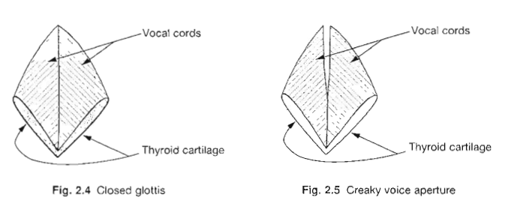

(spoken in Nigeria). Imitating the sound of an unoiled door closing slowly involves creaky voice.

Finally, the vocal cords may be apart (much as for voiceless sounds), but the force of air may still cause some vibration. giving what are known as breathy voice or 'murmured- sounds. found in Hindi (spoken in India) or, for many speakers of English, in the of ' ahead'.

2.1.3 The velum

The position of the velum is the next consideration. The velum, or soft palate, is a muscular flap at the back of the roof of the mouth: this may be raised — cutting off the nasal tract — or lowered — allowing air into and through the nose (see Figure 2.6). When the velum is raised (known as ‘velic closure'). the air can Only flow into the oral tract, that is. the mouth: sounds produced in this way are known as oral sounds (all those in ‘frog', for example). When the velum is lowered, air flows into both mouth and nose, resulting in nasal sounds (the first and last sounds in ‘man’, or the vowel in French *pain* 'bread', for example).

2.1.4 The oral tract

We have thus far considered the type of airstream mechanism involved in the production of a speech sound, the state of the vocal cords (whether the sound is voiced or voiceless, for instance) and the state of the velum (whether the sound is nasal or oral). We must now look at the state of the oral tract: in particular, the position of the active articulators (lower lip and tongue) in relation to the passive articulators (the upper surfaces of the oral tract).

The active articulators are, as their name suggests, the bits that move — the lower lip and the tongue. It is convenient to consider the tongue as consisting of a number of sections (though these cannot move entirely independently, of course). These are: the tip, blade, front, back and root: the front and back together are referred to as the body (see Figure 2.6). The passive articulators are the non-mobile parts — the upper lip, the teeth, the roof of the mouth and the pharynx wall. The roof of the mouth is further subdivided into alveolar ridge, hard palate, soft palate (or velum) and uvula (see, again, Figure 2.6). Consideration of the relative position of active and passive articulators allows us to specify what are known as the manner of articulation and the place of articulation of the speech sound. These will be discussed in detail in the following two chapters: for the moment, a brief survey will suffice.

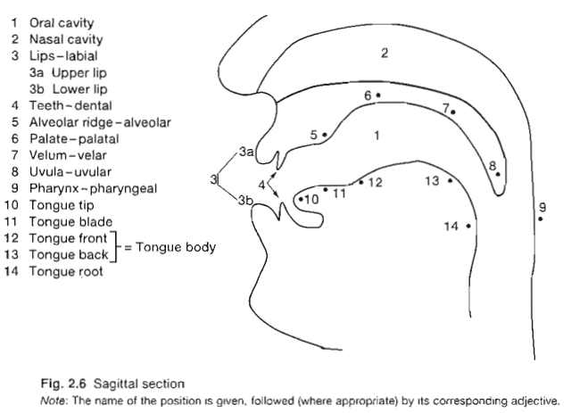

2.1.5 Manner of articulation

Manner of articulation refers to the vertical relationship between the active and passive articulators, i.e. the distance between them (usually known as stricture): anything from being close together, preventing air escaping, to wide apart, allowing air to flow through unhindered.

When the articulators are pressed together (known as complete closure), a blockage to the airflow is created, causing air pressure to build up behind the blockage. When the blockage is removed the air is released in a rush. The sounds produced in this way are known as stops; these may be oral (with velum raised), as in the first and last sounds in 'bad', or nasal (lowered velum), as in the first and last sounds in ‘man' — the only difference between these words is the position of the velum, since the active articulators are in the same positions for both words.

The first and last sounds in ‘church' also involve complete closure, but have a different release of air. In the oral stops we have looked at so far, the active articulator is lowered completely, giving a wide ‘escape hole’ for the air, as for the stop sounds in ‘bad': for the first and last sounds in the active articulator is lowered only slightly. giving a slower release of the air through a narrow channel between the articulators. As the air passes through this narrow space there is friction (see fricatives in the next paragraph). Sounds produced in this way are known as affricates.

When the articulators are close together, but without complete closure (a stricture known as close approximation), the air is forced through the narrow gap between the articulators, causing some turbulence; sounds so produced are known as fricatives (the first and last sounds in ‘fez').

For the other major sound types — liquids, glides and vowels — there is free passage of air through the oral tract. though the exact relation between the articulators will vary. For vowels (the middle sounds in ‘cat’. ‘dog'. ‘meat', etc.) and glides (sometimes known as 'semi-vowels') (the initial sounds in ‘yak' and 'warthog'), the articulators are wide apart and the air flows out unhindered (this is known as open approximation). For liquids (the first and last sounds in ‘rail'), there is both contact and free air passage: for the 'r' sound. the sides of the tongue are in contact with the gums. but the air flows freely down the centre of the tongue, and for the ‘l' sound. the centre of the tongue is in contact with the alveolar ridge but the air flows out freely over the lowered sides of the tongue —see Section 3.5.

2.1.6 Place of articulation

Place of articulation refers to the horizontal relationship between the articulators. It specifies the position of the highest point of the active articulator (usually some part of the tongue. but the lower lip may also be the active articulator) in relation to the passive articulator. The passive articulator involved typically gives its name to the place of articulation. The major places of articulation are shown in Table 2.1. In Table 2.1 most places of articulation are self-explanatory to the English speaker (see Figure 2.6). Let us mention here two that are not: retroflex and pharyngeal. A retroflex sound involves a particular shape of the tongue as well as a horizontal relationship between the articulators. The tongue tip is curled towards the back or the mouth. Such sounds may be heard in Indian English for ‘t' and ‘d', due to the influence of native languages of the Indian subcontinent, many of which have retroflex consonants. A pharyngeal sound involves moving the root of the tongue towards the back of the throat, i.e. the pharynx wall. Such sounds are common in many varieties of Arabic and Hebrew. It is also possible for a speech sound to have two places of articulation simultaneously, known as ‘dual articulations'. The articulations may be of equal importance, as in the initial labial-velar sound in ‘wombat', involving as active articulators the lower lip and the back of the tongue, or one place may be ‘added on' to another (primary) place. This latter situation is found, for example, in the palatalised stops of Slavic languages such as Polish

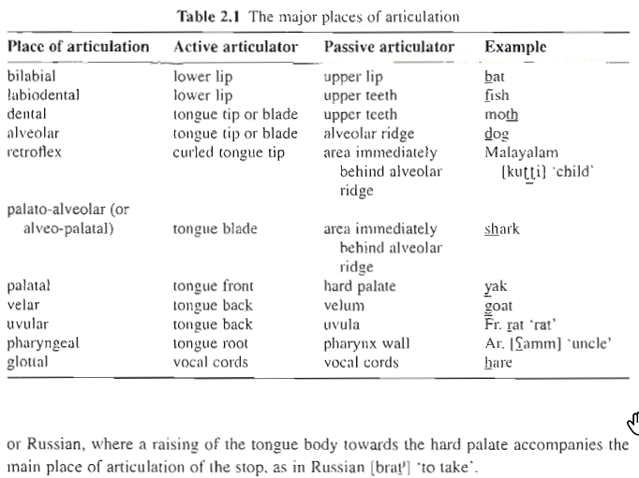

or Russian, where a raising of the tongue body towards the hard palate accompanies the main place of articulation of the stop, as in Russian [brat̪ʲ] 'to take'.

2.2 Speech sound classification

We now have a method of describing the articulation of any speech sound by specifying (1) the airstream mechanism, (2) the state of the vocal cords, (3) the position of the velum, (4) the place of articulation and (5) the manner of articulation. Thus, the first sound in 'pig’ could be classified — using these five features — as a pulmonic egressive, voiceless, oral, bilabial stop.

In fact, for consonants, it is more usual to use a three term classification, referring to voicing, place and manner, with airstream and velum only referred to when they are not pulmonic egressive and oral respectively; thus the ‘p' sound in ‘pig' is normally referred to as a voiceless bilabial stop. 'z' as in ‘fez' is a voiced alveolar fricative. For vowels, the classification is slightly different: voicing is typically irrelevant, since in most languages, vowels are always voiced, and the vertical (manner for consonants) and horizontal (place for consonants) dimensions are more restricted. All vowels are produced with a stricture of open approximation, so manner as such is irrelevant: however, different vowels do involve differences in the highest point of the tongue: for the vowel sound in ‘sit' the tongue is higher than for the vowel sound in ‘sat'; we refer to ‘high', ‘mid' and ‘low’ vowels. Horizontally, vowels are restricted to the palatal and velar regions; compare the vowels in 'fee' (made in the palatal area) and ‘for’ (made further back in the velar area); in this dimension we refer to vowels as ‘front’, ‘central' and ‘back'. There is a further consideration for vowels, however, not usually relevant for consonants: that of lip rounding. (Note that even though the upper lip is considered a passive articulator, it does participate in lip rounding.) The vowel sound in 'see' involves no lip rounding, while the lips are rounded for the vowel sound in 'sue': you can check this by looking in a mirror as you say these sounds. Thus the vowel sound in 'see' can be referred to as a high front unrounded vowel, that in as a mid back round vowel.

2.3 Supra-segmental structure

Thus far, we have considered speech sounds, or segments, as individual units. When we use speech, however, we do not produce segments as individual items: rather, they are part of larger constructions. One such 'larger construction' that sounds can be combined together to form is the syllable. Coming up with a straightforward definition of the syllable is no easy task (but see Section 6.1.1 for some discussion): speakers nonetheless have an intuitive idea of what the syllable is. We can, for instance, count them, or tap in time to them, quite easily: most speakers of English would agree that the word ‘rabbit' has two syllables, that 'elephant’ has three syllables and that 'armadillo' has four. While all these syllables are different, in the sense that they are made up of different segments. they nonetheless share certain structural properties: they all have a vowel. and this vowel may be preceded and/or followed by one or more consonants: the first syllable of ‘elephant' is just the vowel represented orthographically as the second is a vowel preceded by a consonant ‘le’, and the third is a vowel preceded by one consonantal sound (orthographically ‘ph') and followed by two consonant segments, so, while consonants appear to be optional in syllable structure, vowels seem to be obligatory. The facts are actually more complex than this. since many languages, including English, allow nasals and liquids to form a syllable without a vowel, e.g. ‘bottle'. These liquids and nasals are known as syllabic. The vowel is said to be the peak or nucleus of the syllable, with any consonants preceding the nucleus said to be in the syllable onset, and any following the nucleus said to be in the syllable coda, so the first syllable in ‘rabbit’ has an ‘r’ sound in the onset, the vowel represented by ‘a' in the nucleus. and no coda: (the second syllable has a single consonant in the onset (even though the orthography has two symbols, 'bb'), the vowel represented by ‘i’ as the nucleus. and a single coda consonant ‘t’. As well as being aware of how many syllables there are, speakers can usually also recognise that when we have a sequence of syllables, making up a word or a sentence, some syllables are ‘stronger' or ‘more noticeable' than others. Thus, in ‘rabbit’ and 'elephant’ the first syllable is more noticeable than the others, whereas in ‘armadillo' it's the third syllable that is most noticeable: in a sentence like ‘Albert went to the zoo’ we can usually agree that the final syllable (‘zoo') is more prominent than any of the others. That is, we can recognise that some syllables carry more stress than others. Stressed syllables produced with more muscular effort, and are louder and longer than unstressed syllables. We shall have more to say about syllables and stress in Chapter 6.

2.4 Consonants vs. vowels

Syllable structure plays a role when we attempt to clarify a major distinction between speech-sound types that we have thus far simply been assuming: that between consonants and vowels. This is not as straightforward as if might at first appear: at first glance, the essential difference would seem to have to do with degree of stricture, i.e. the distance between the active and passive articulators. For consonants there is some kind of obstruction in the oral tract, whereas for vowels there is no such hindrance to the outflow of the air. Thus, stops (oral and nasal), fricatives and liquids all involve a stricture of at least close approximation. Liquids and nasals might appear to be counterexamples to this claim, since the air flows out freely for these sound types. In each case, however, there is some obstruction in the oral tract; for nasals, complete closure (since they are stops). For liquids, there is some contact between articulators, but this does not extend across the full width of the oral tract — so. for the ‘l' in ‘lion', the middle of the tongue tip is in contact with the alveolar ridge, but the sides of the tongue are lowered, allowing free airflow.

The class of glides is a problem for this definition, however, since for them there is a stricture of open approximation. For these sounds, the consonant/vowel distinction rests not so much with the phonetics as with the phonology. That is, it has to do with how the sounds function in the language, rather than with the details of their articulation. True vowels like the ‘i’ in ‘pig’ are syllabic: that is, they comprise the essential part of the syllable, known as the nucleus, and without which there would not be a syllable (for details of syllable structure, see Section 2.3 and Chapter 6). Glides, on the other hand, behave like consonants in that they do not form the nuclei of syllables, but rather occur on the edges of syllables. That is, the main difference between the ‘y’ in ‘yak' and the 'i' in ‘pig, is not so much the articulation (which is much the same, though the ‘y' may well be somewhat shorter), but the function of the two sounds. In ‘pig’ the segment represented by 'i’ is the nucleus (or head) of its syllable, in 'yak’ the segment represented by ‘y' is not the nucleus (the ‘a' is), but rather the onset. So we might say for English and many other languages that a vowel is a sound produced with open approximation and which is a syllable nucleus: (his will exclude glides, which are not nuclei. and will also exclude syllabic liquids and nasals (as in the final sounds of 'throstle’ and 'mutton') since these are not produced with open approximation.

CONSONANTS

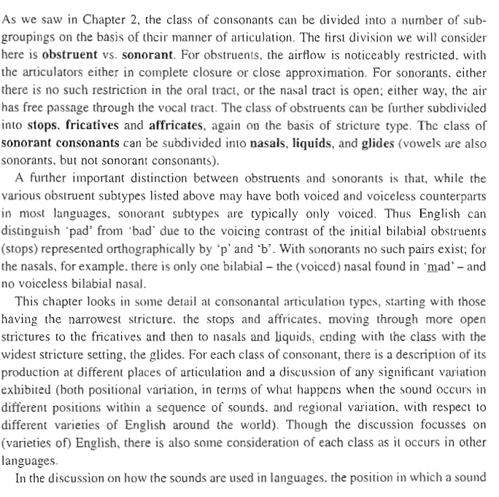

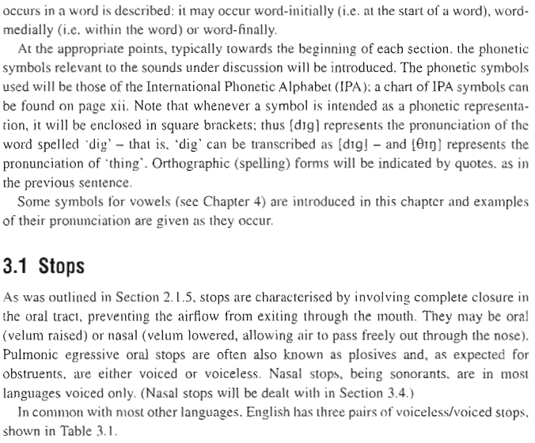

MANNER

Stops

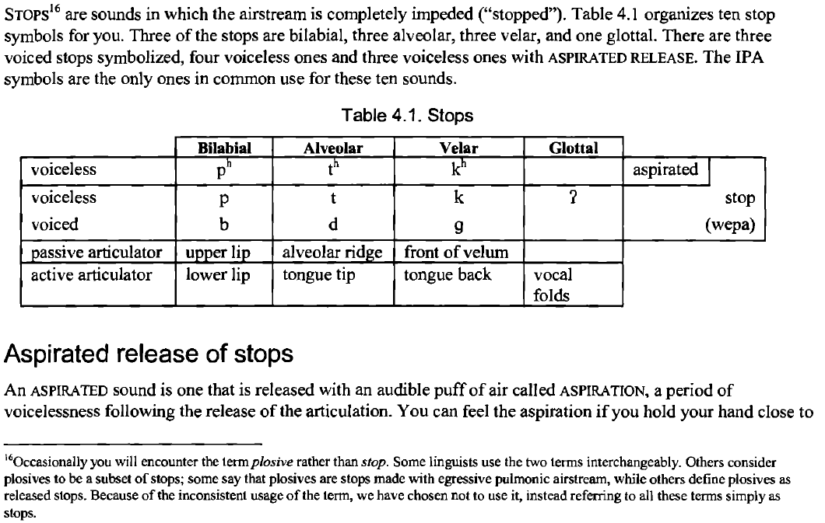



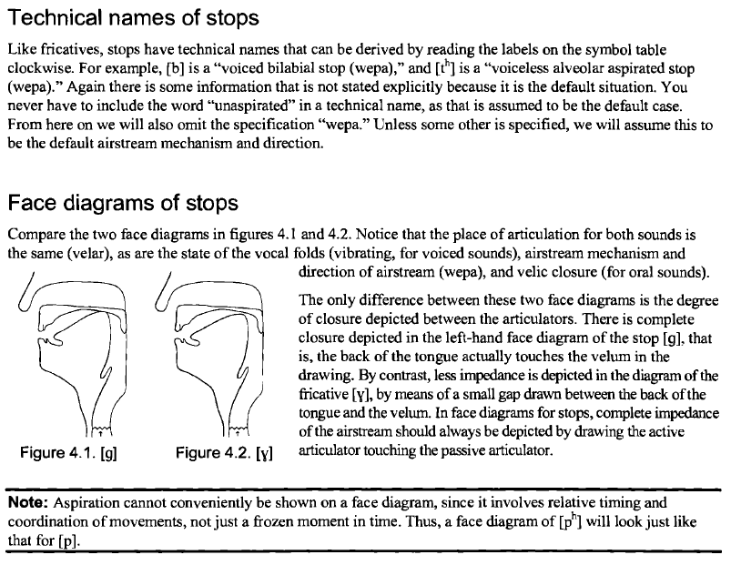

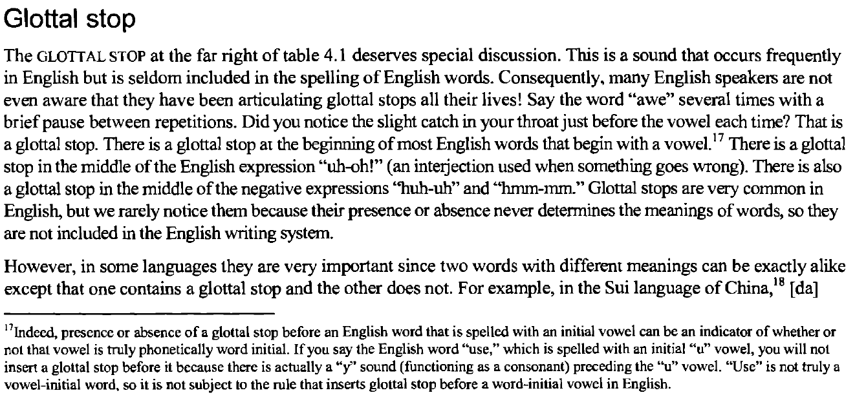

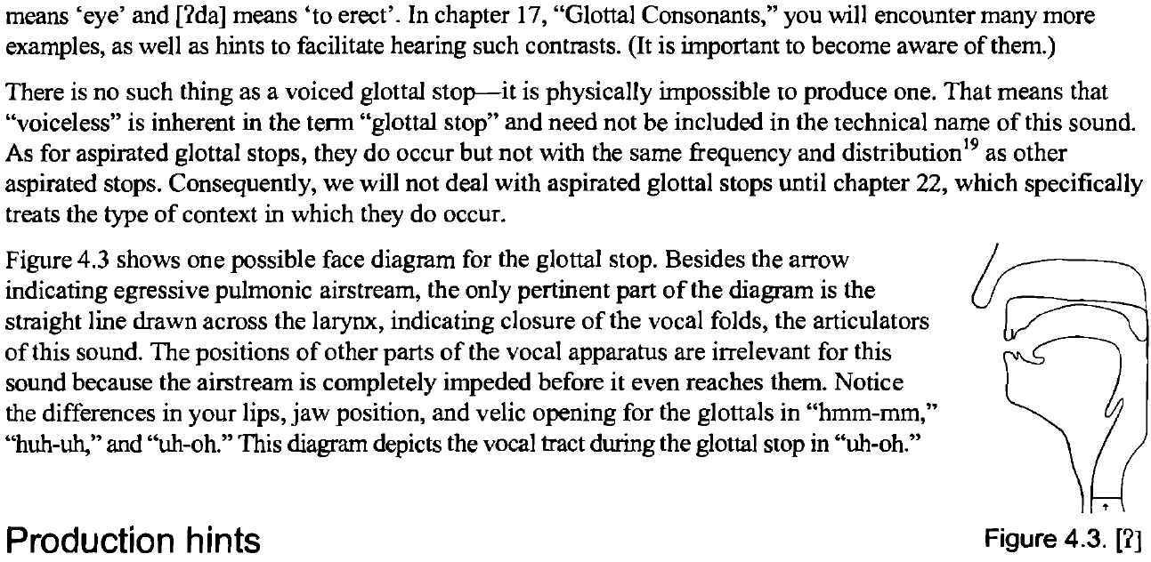

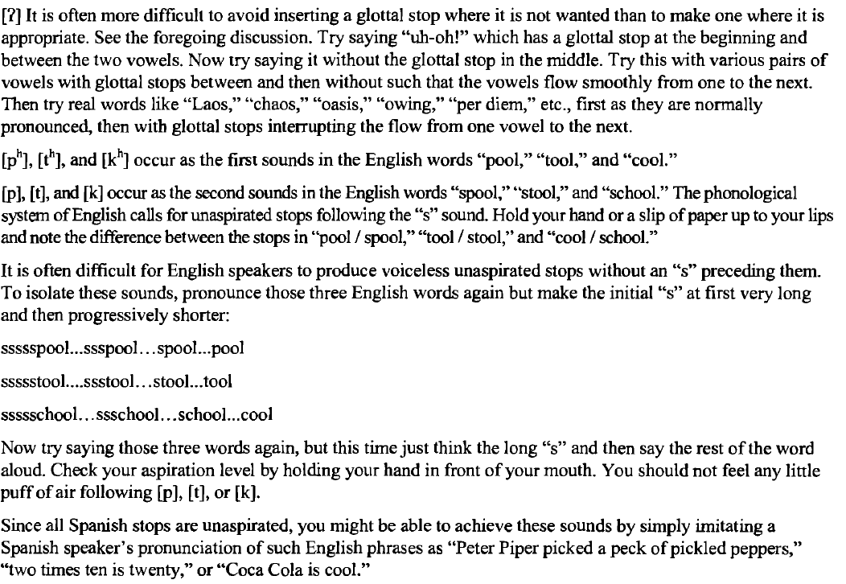

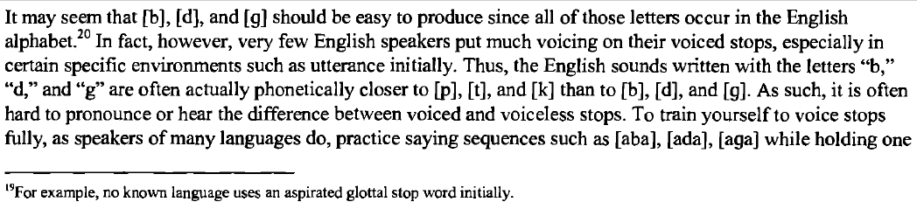

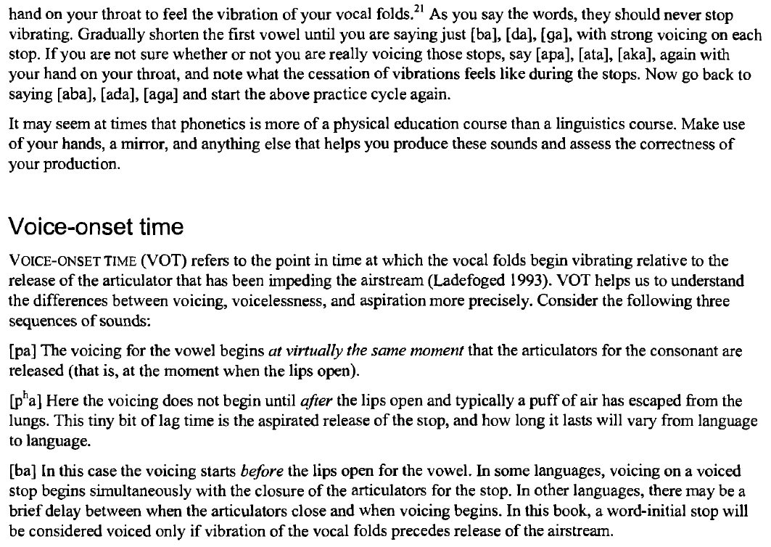

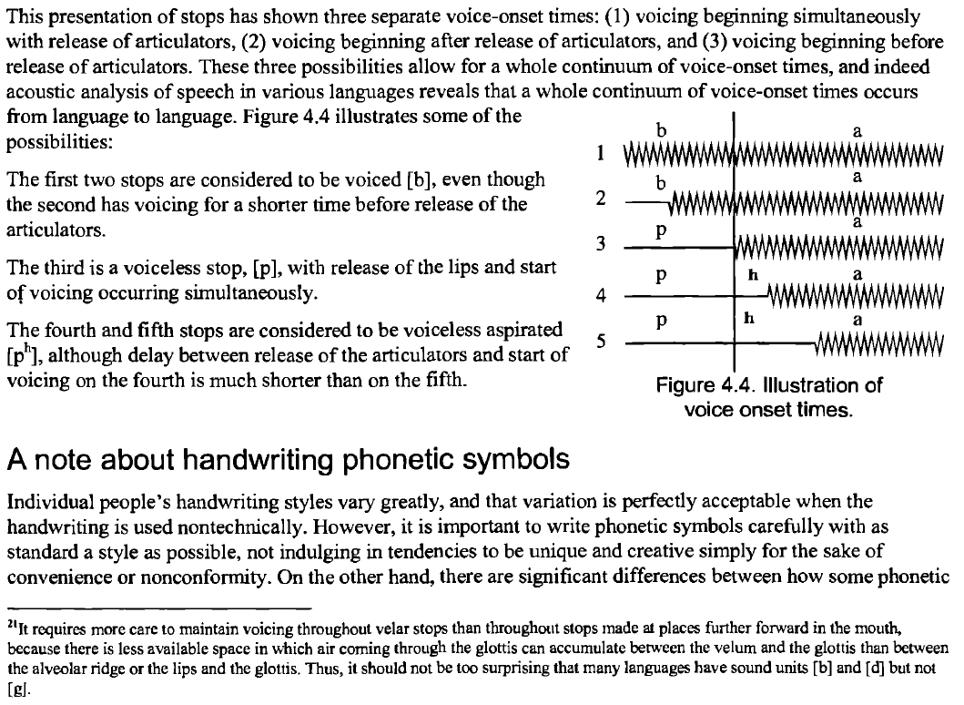

Fricative

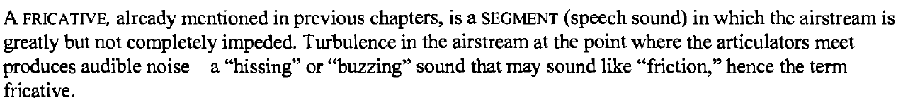

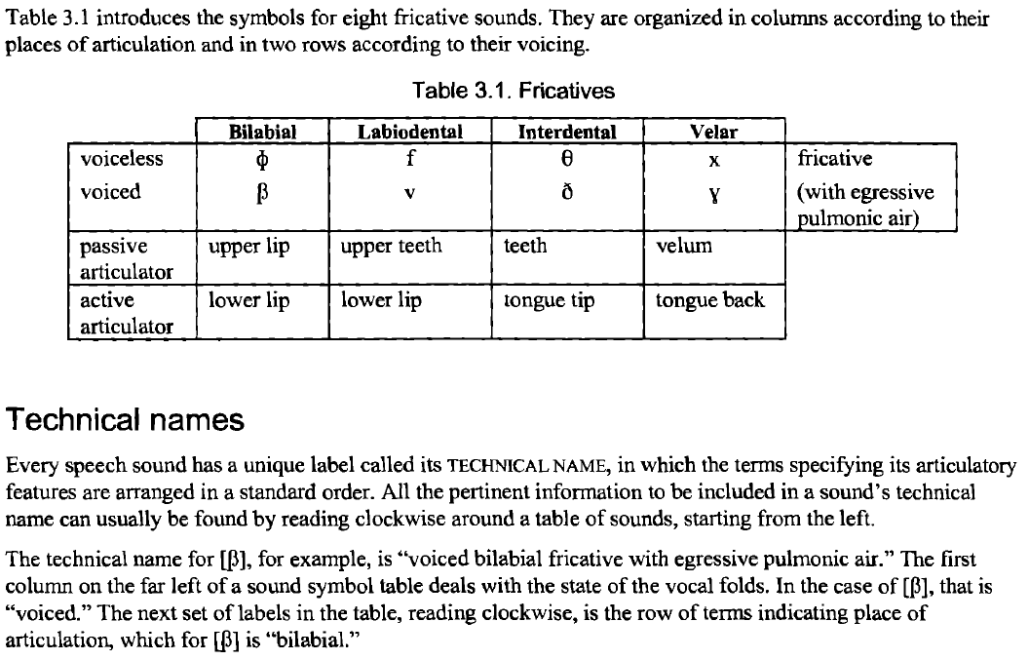

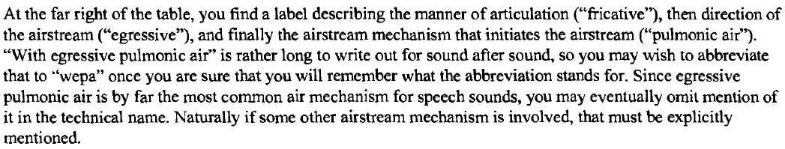

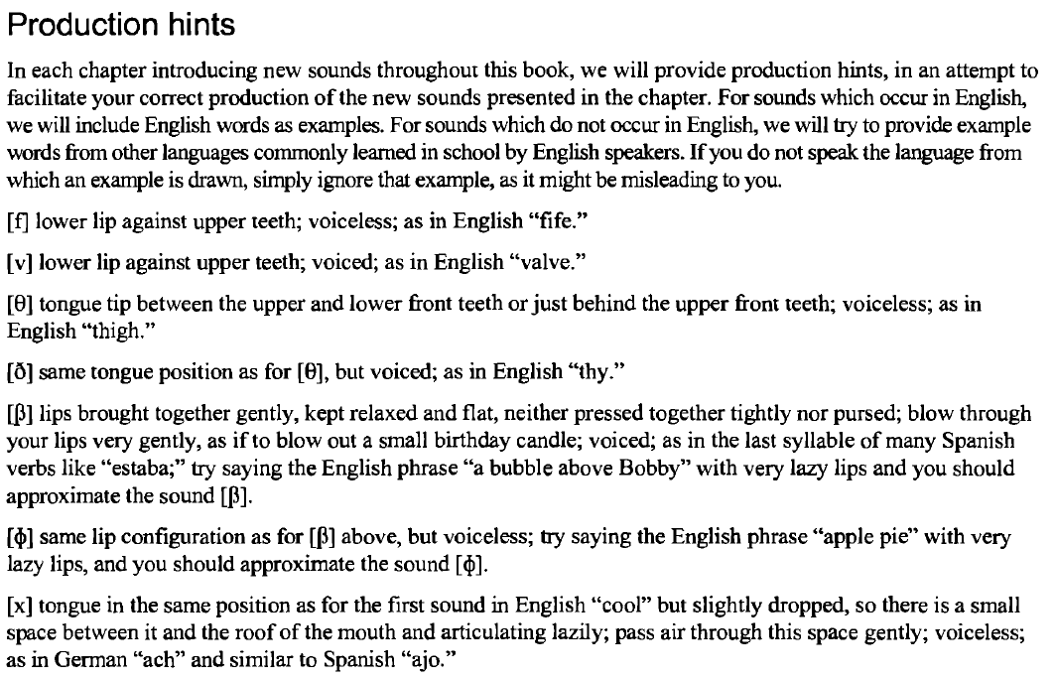

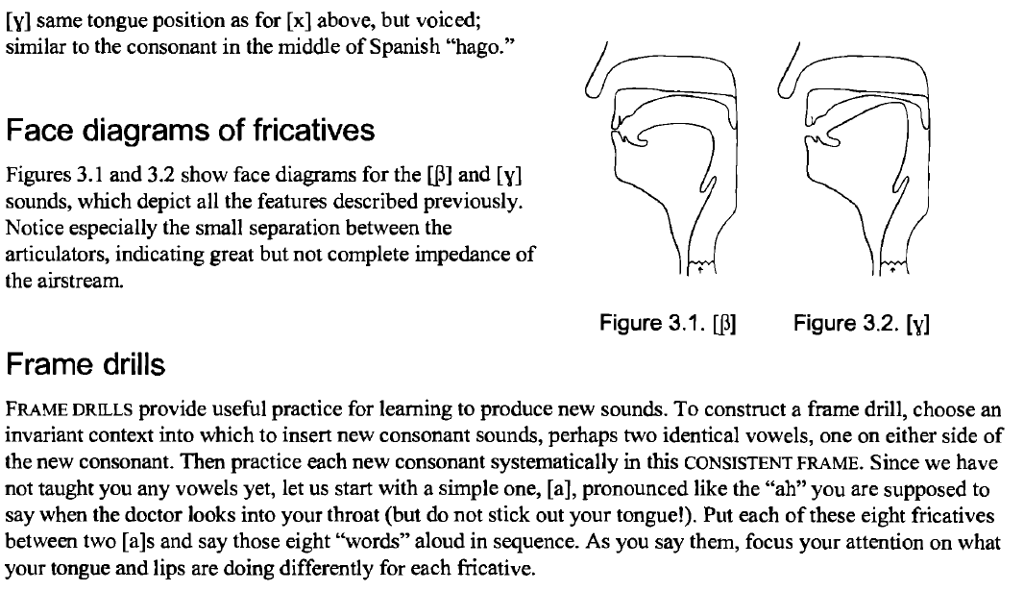

nasal

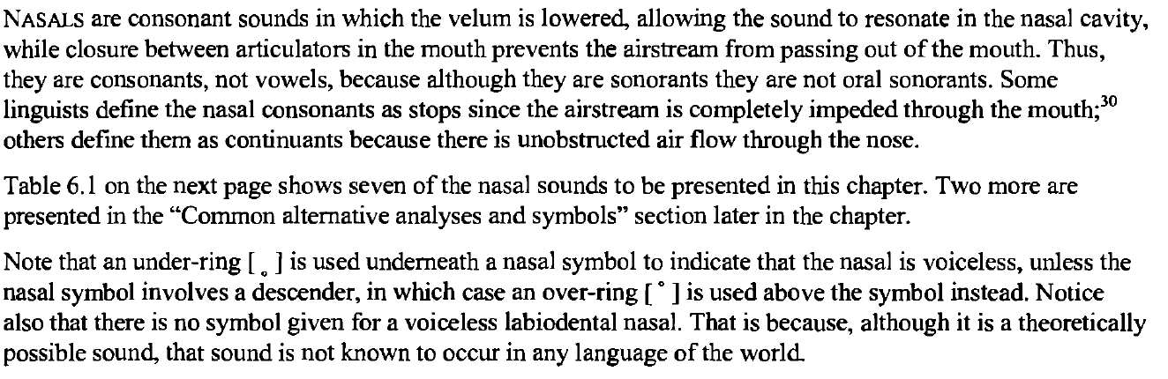

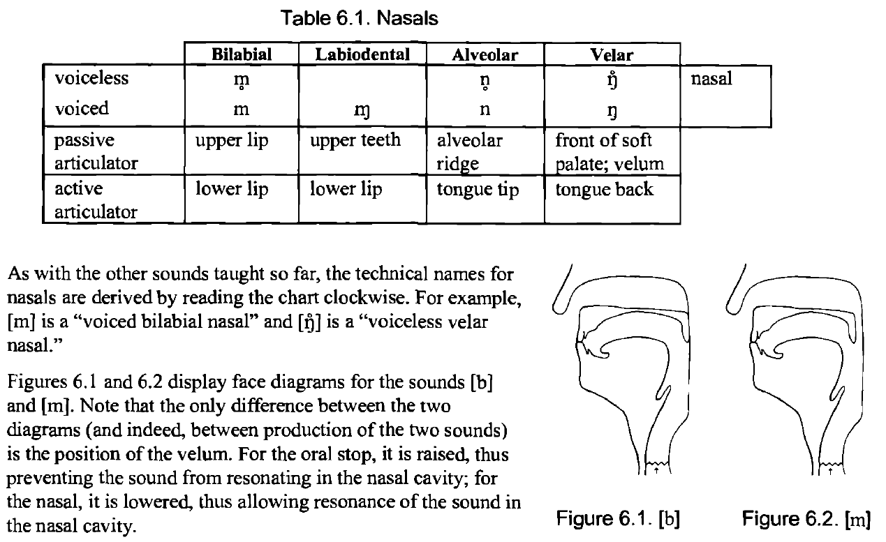

sibilants

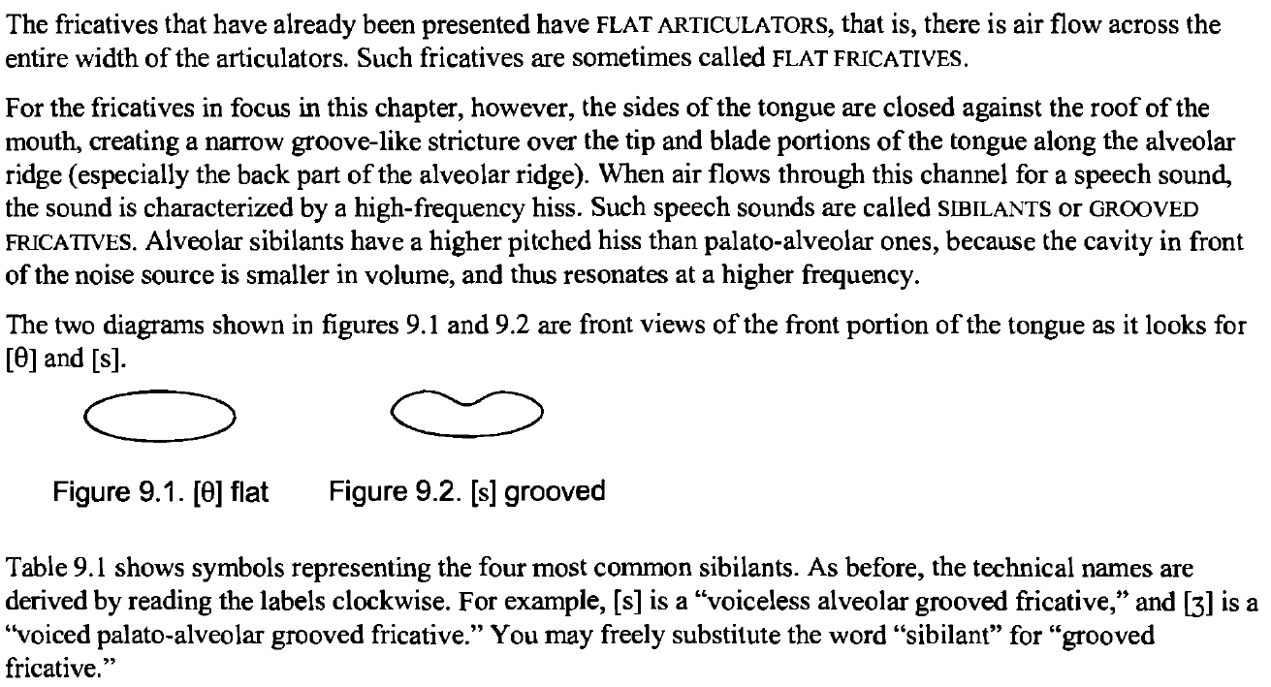

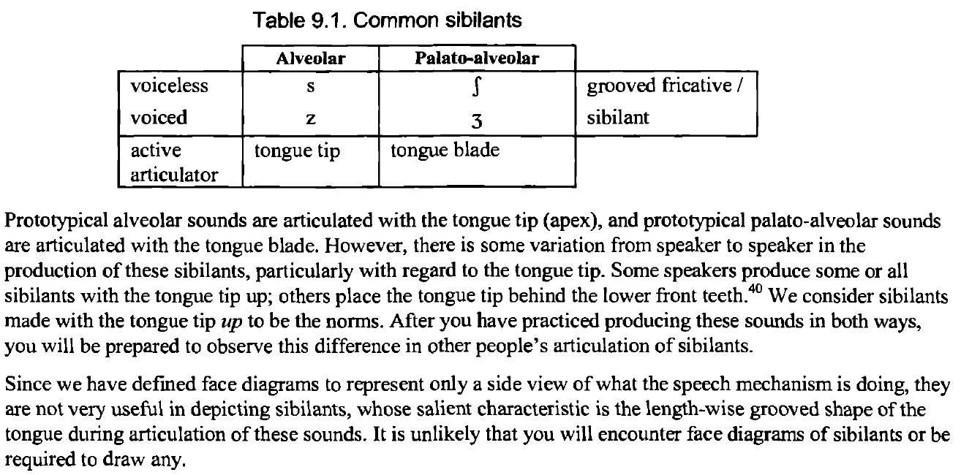

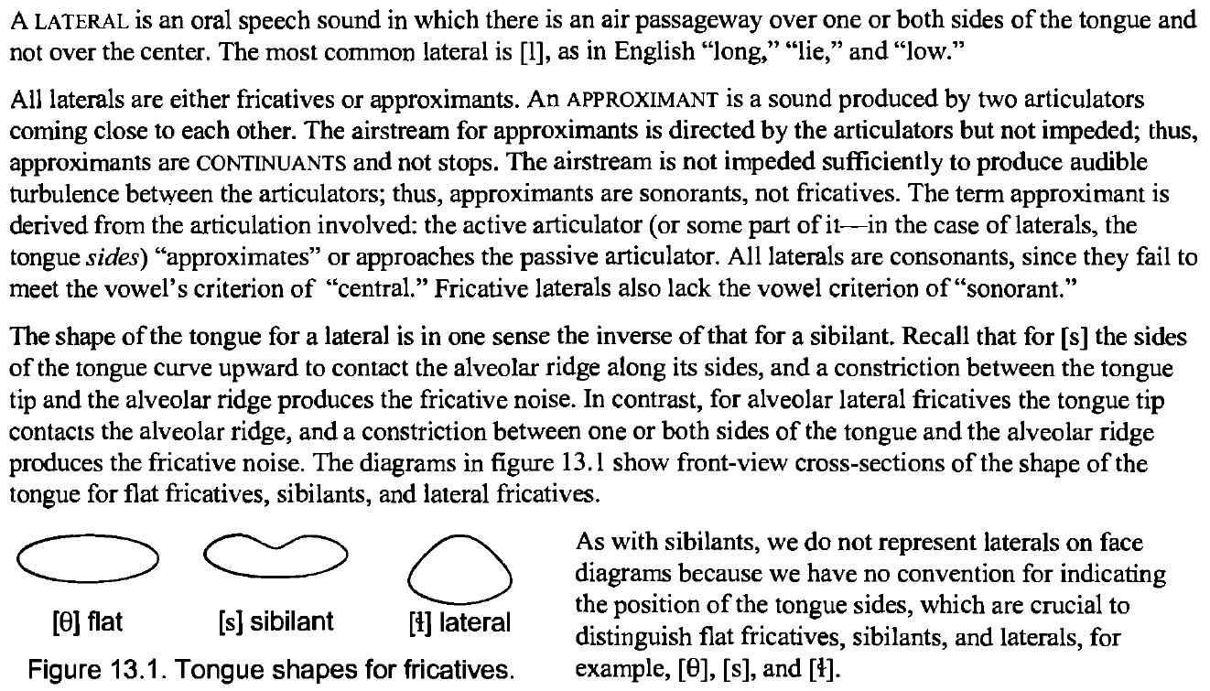

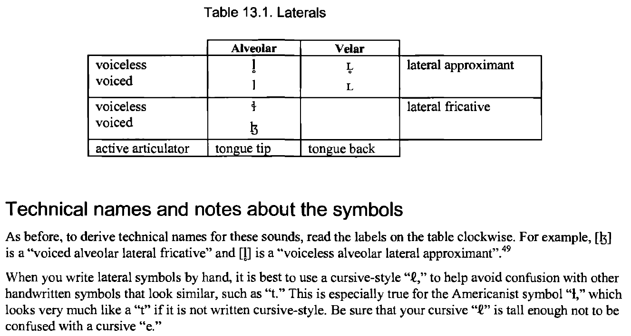

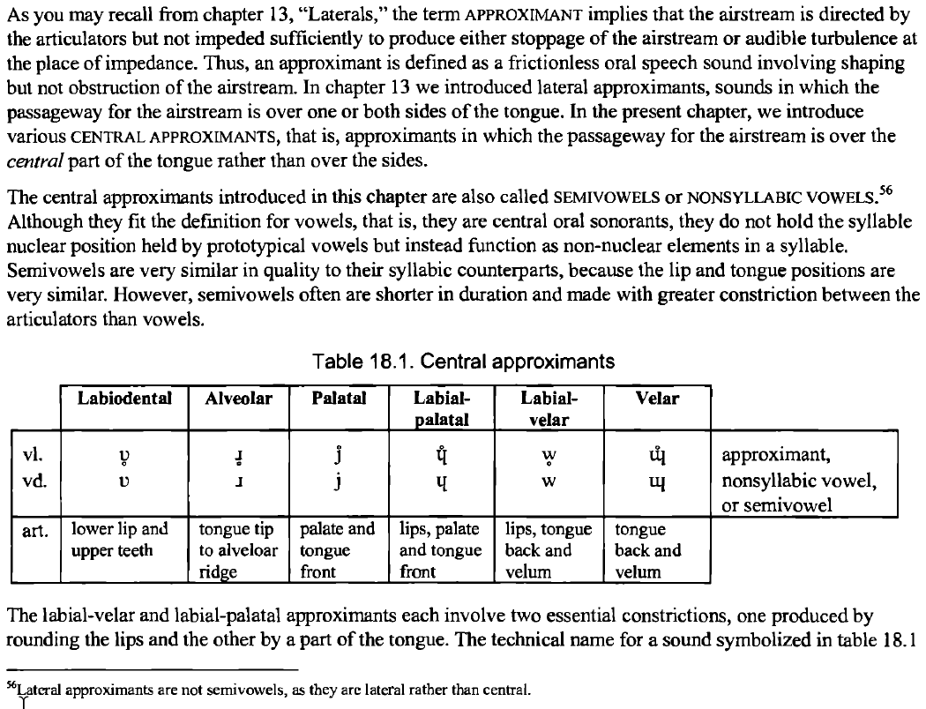

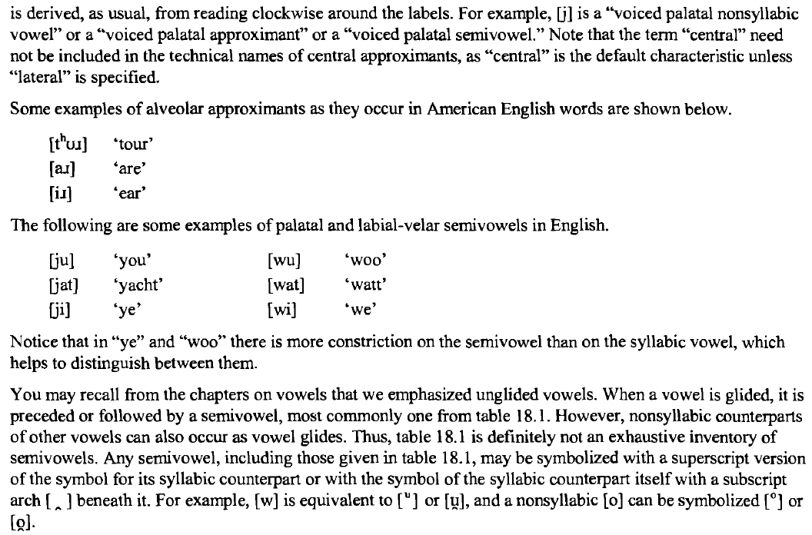

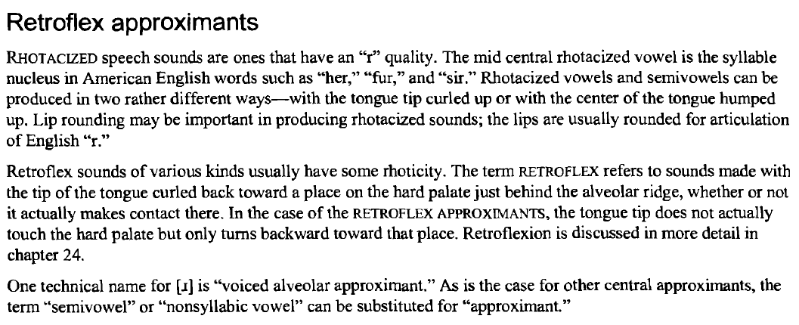

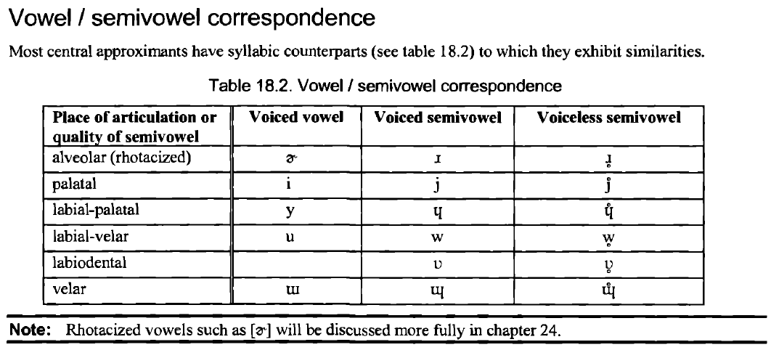

Ejective

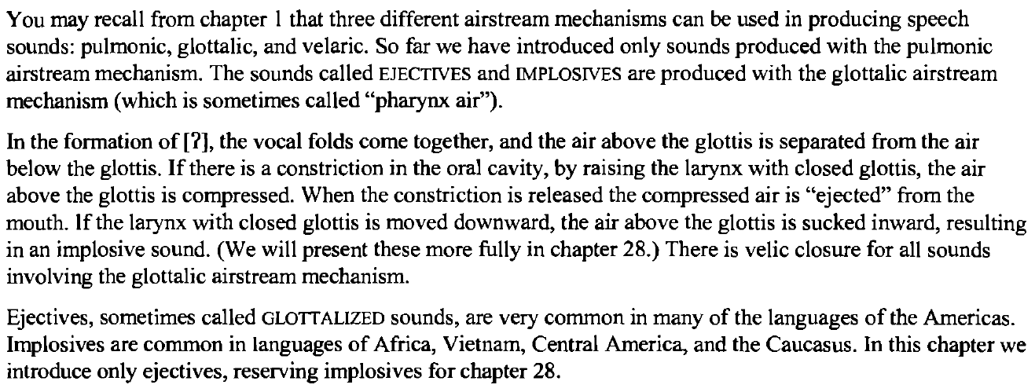

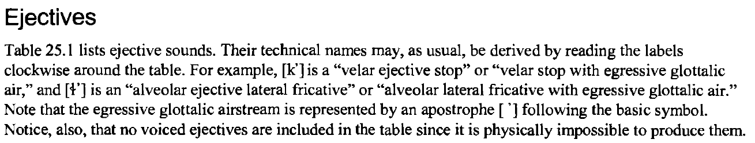

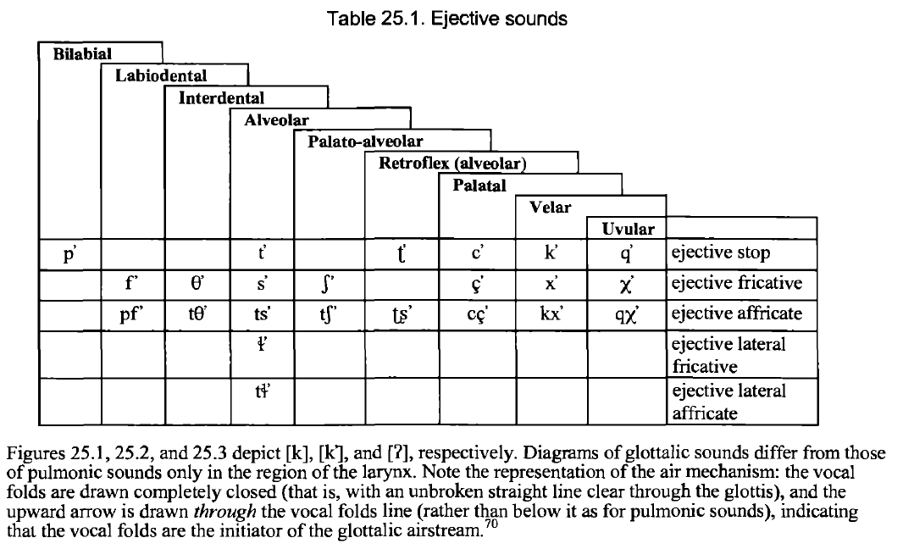

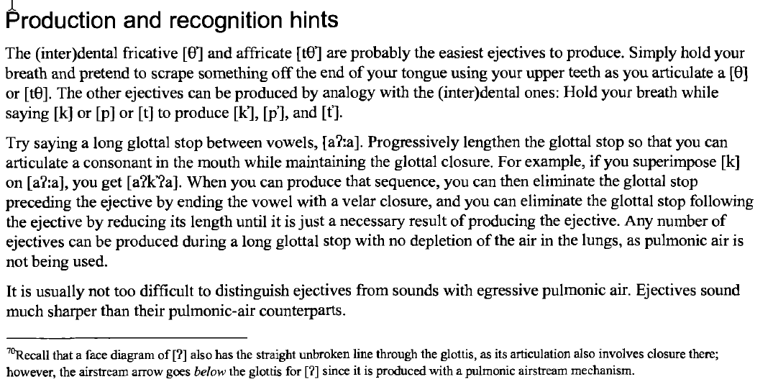

Implosive

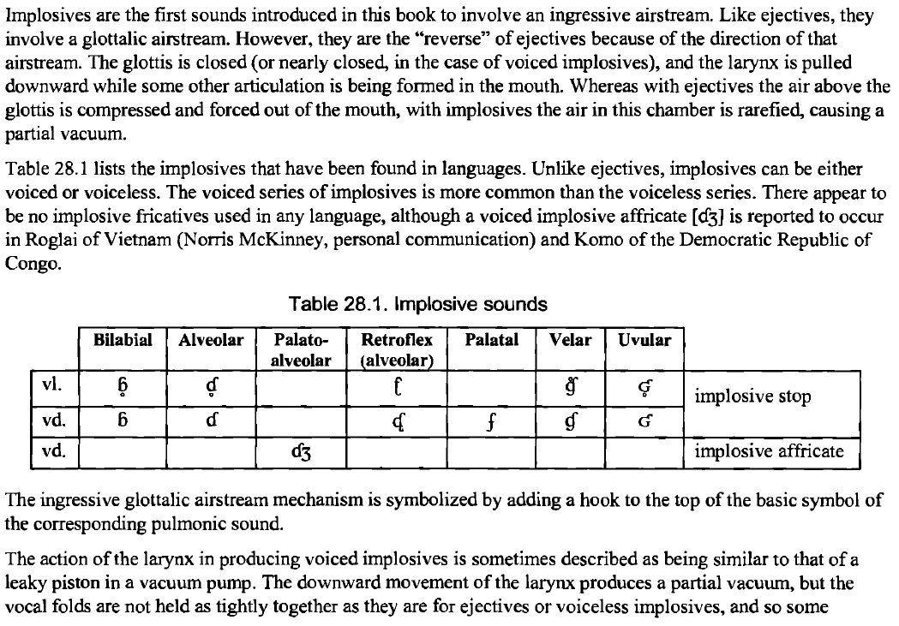

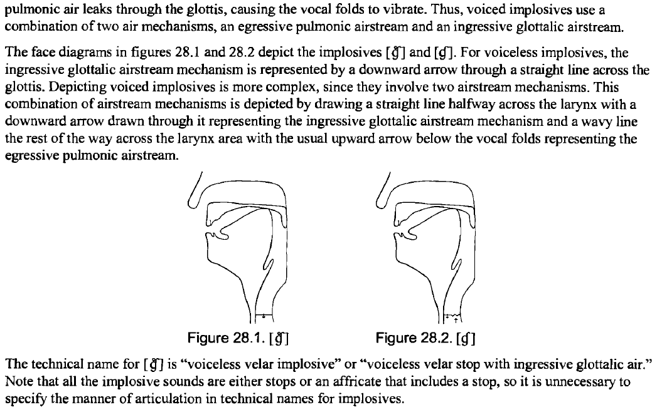

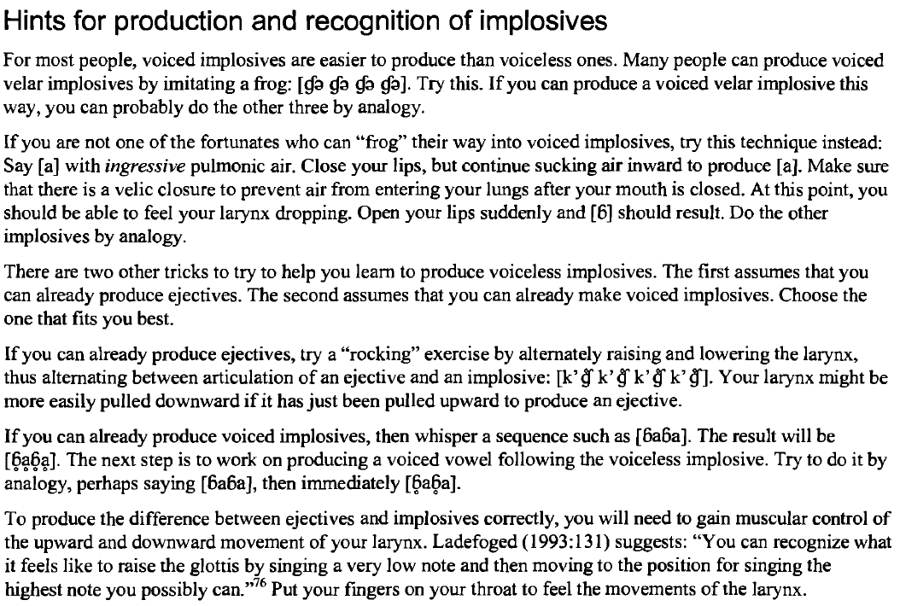

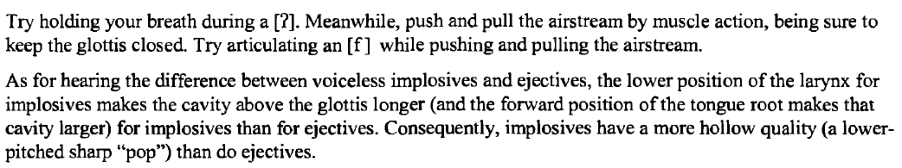

Click

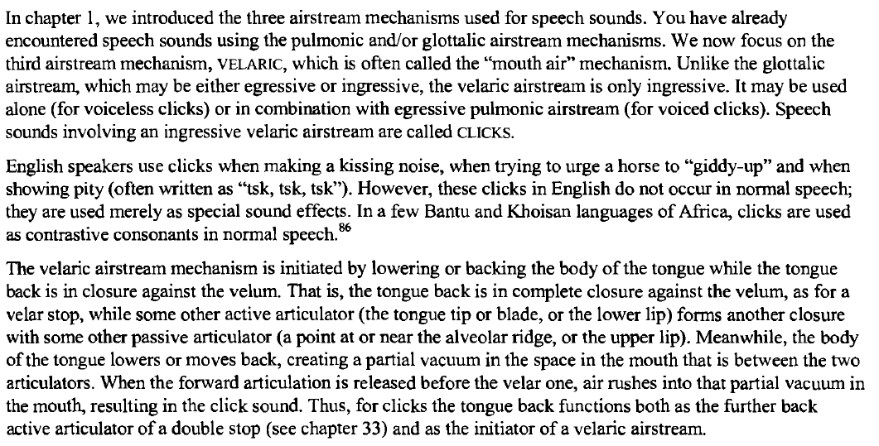

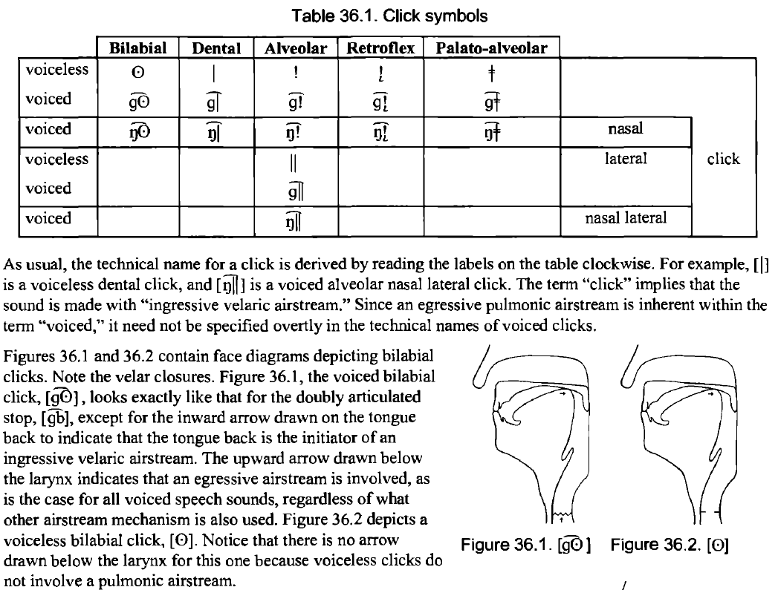

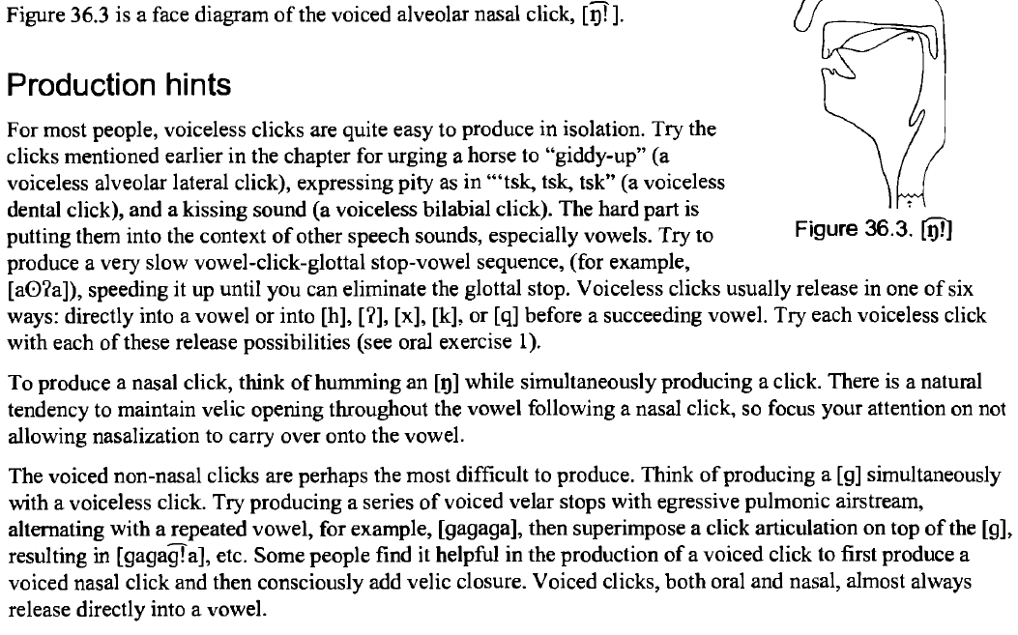

OTHER

Fronting, retroflexion

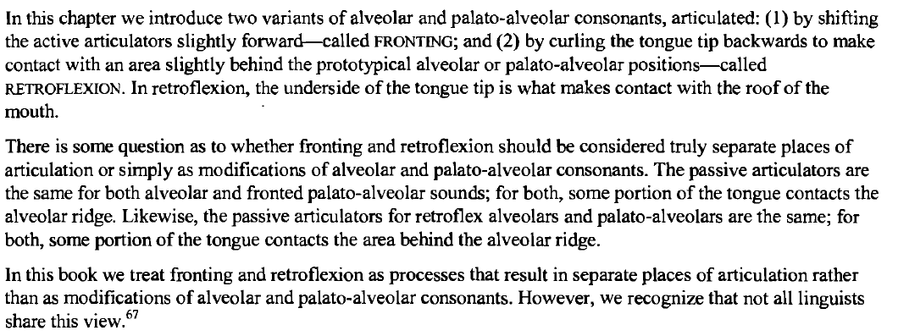

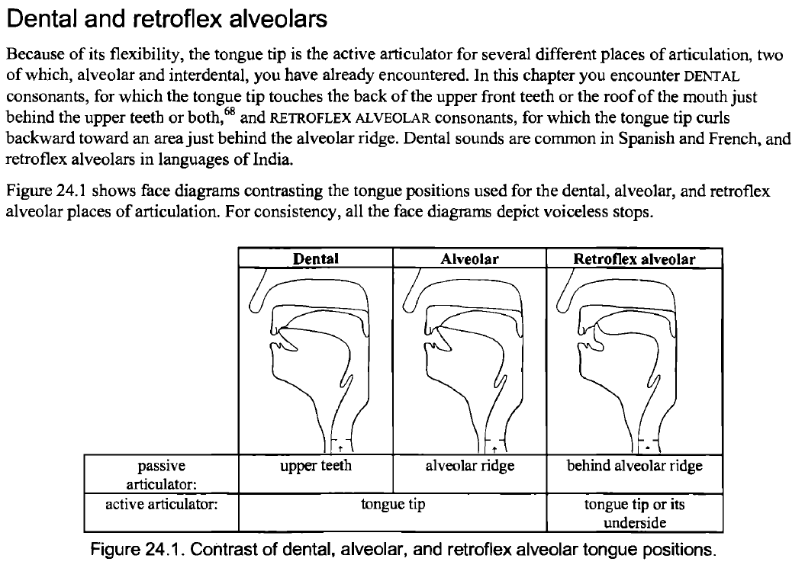

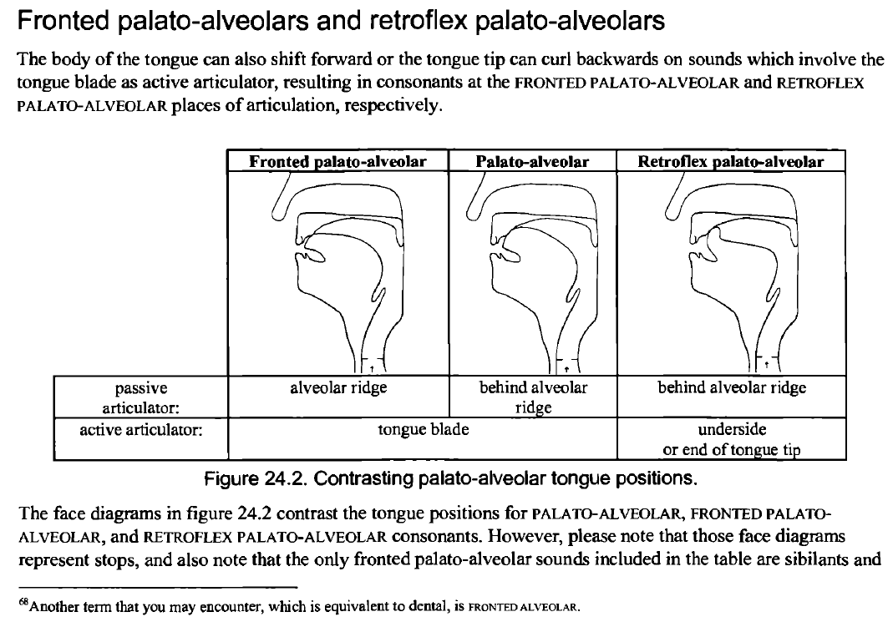

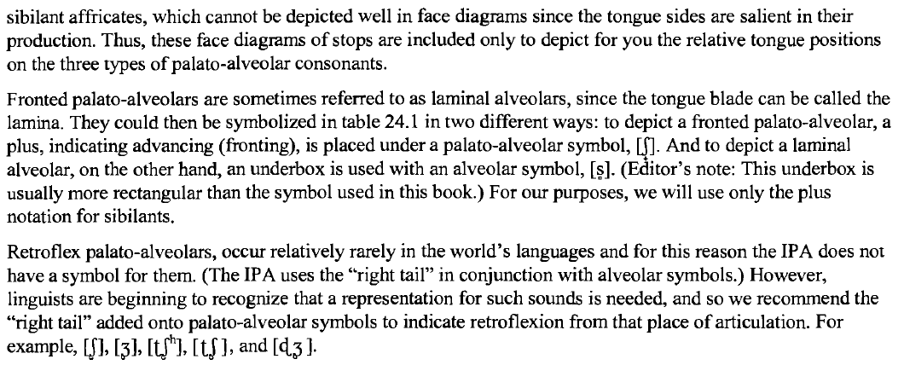

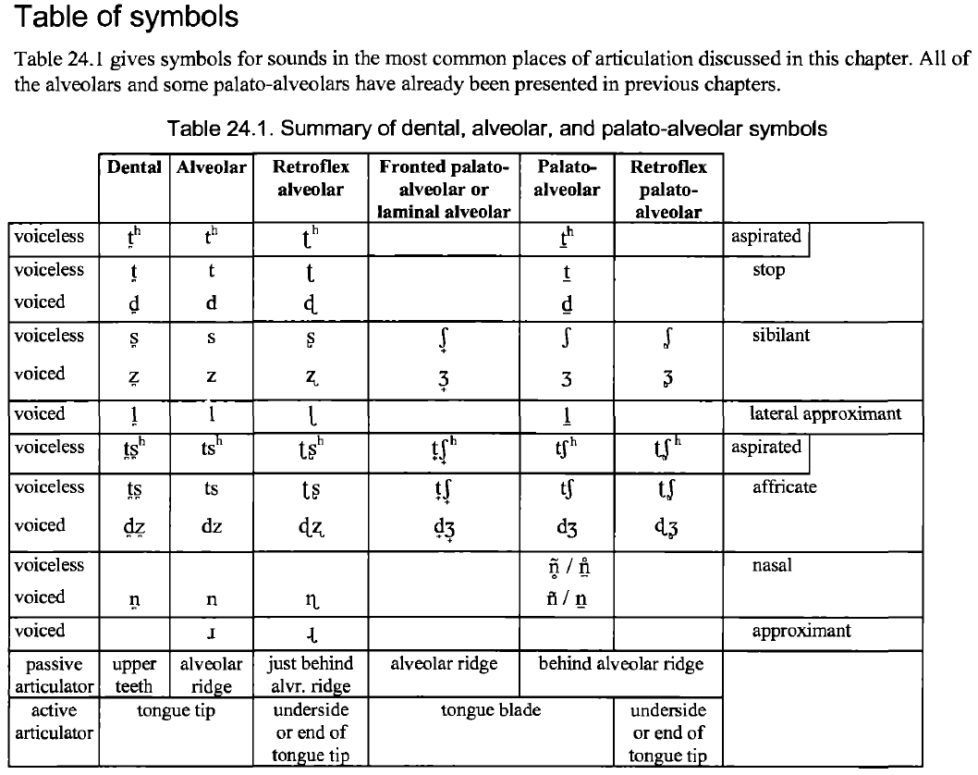

double artic

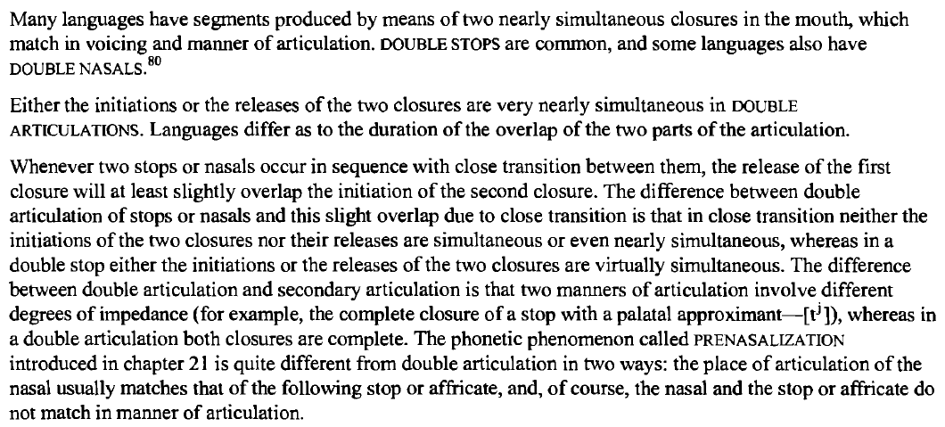

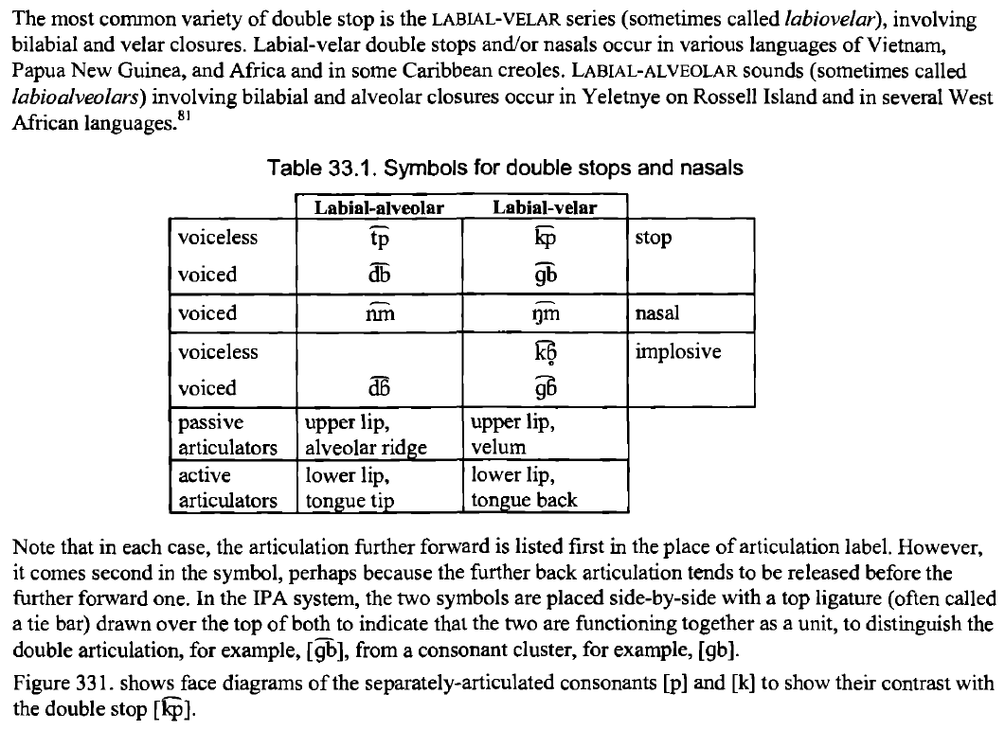

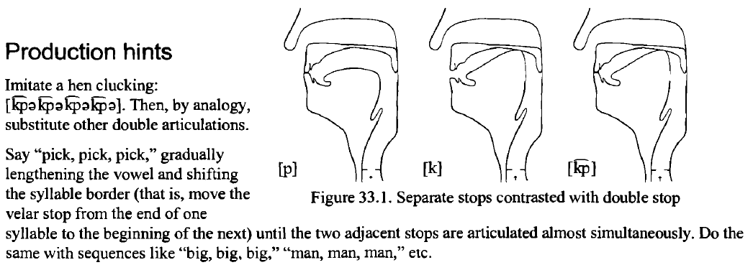

secondary articulations

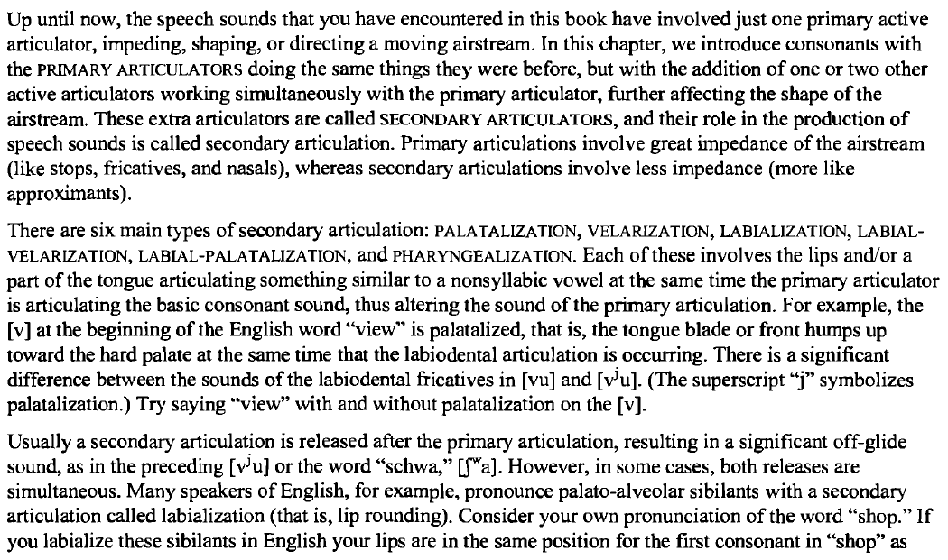

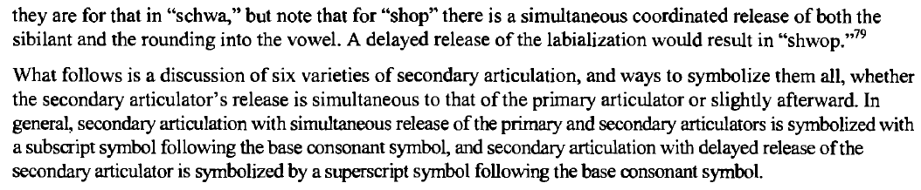

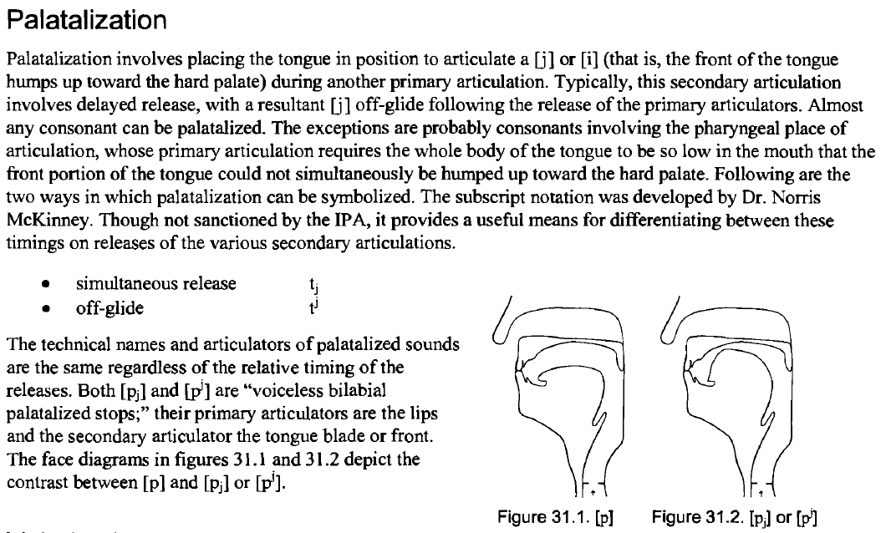

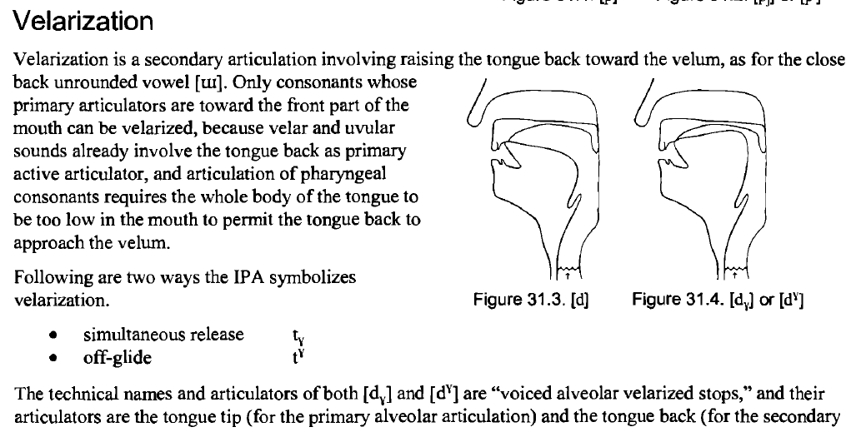

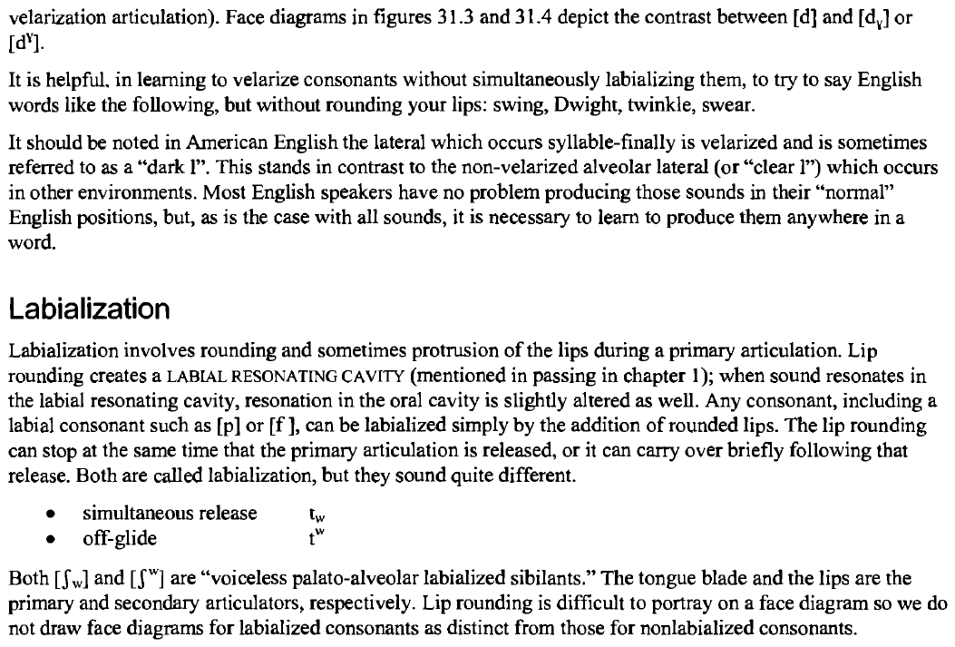

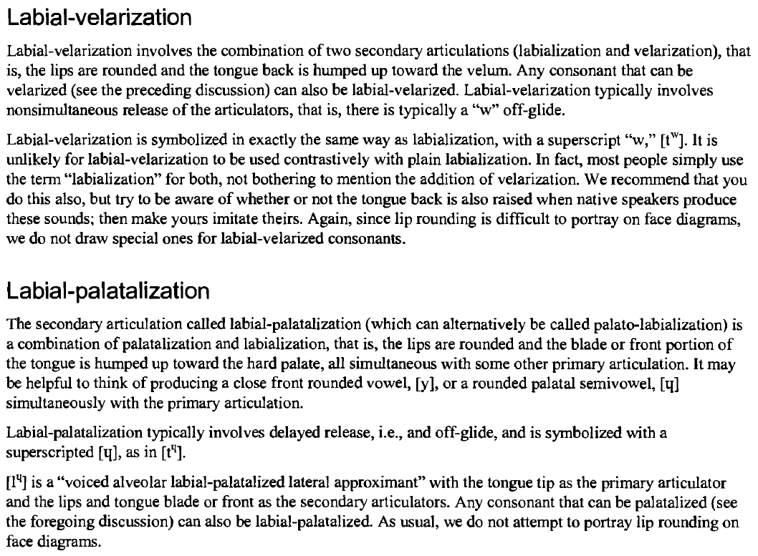

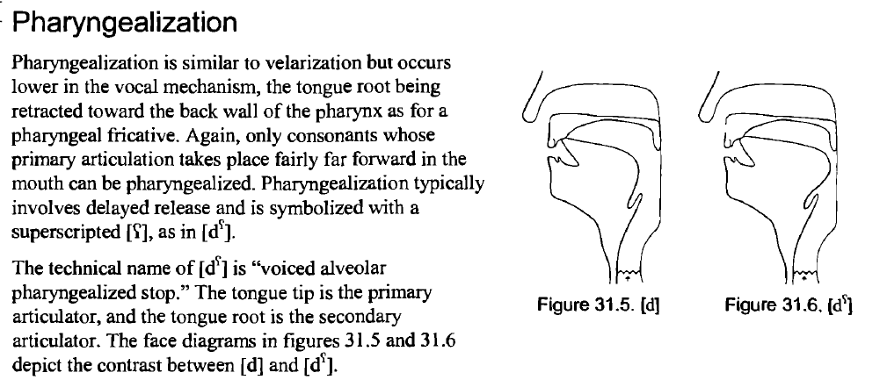

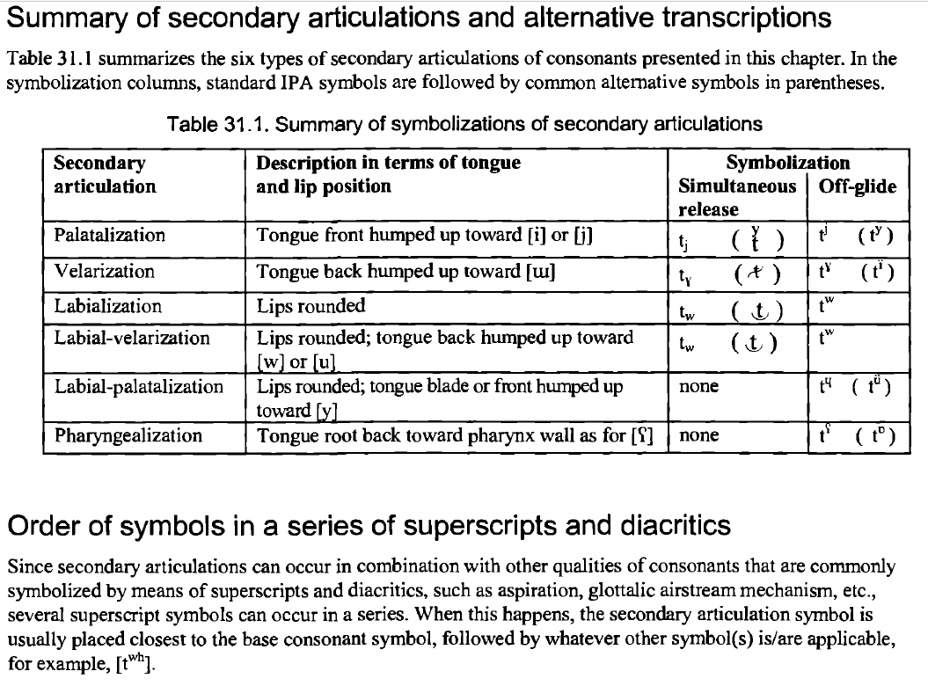

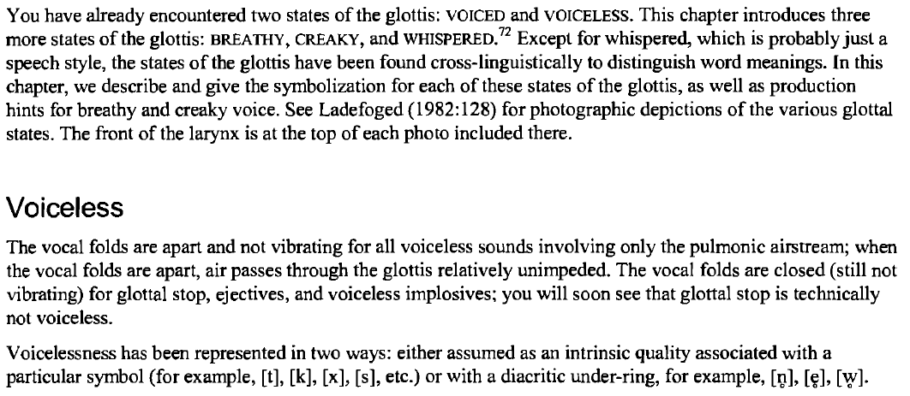

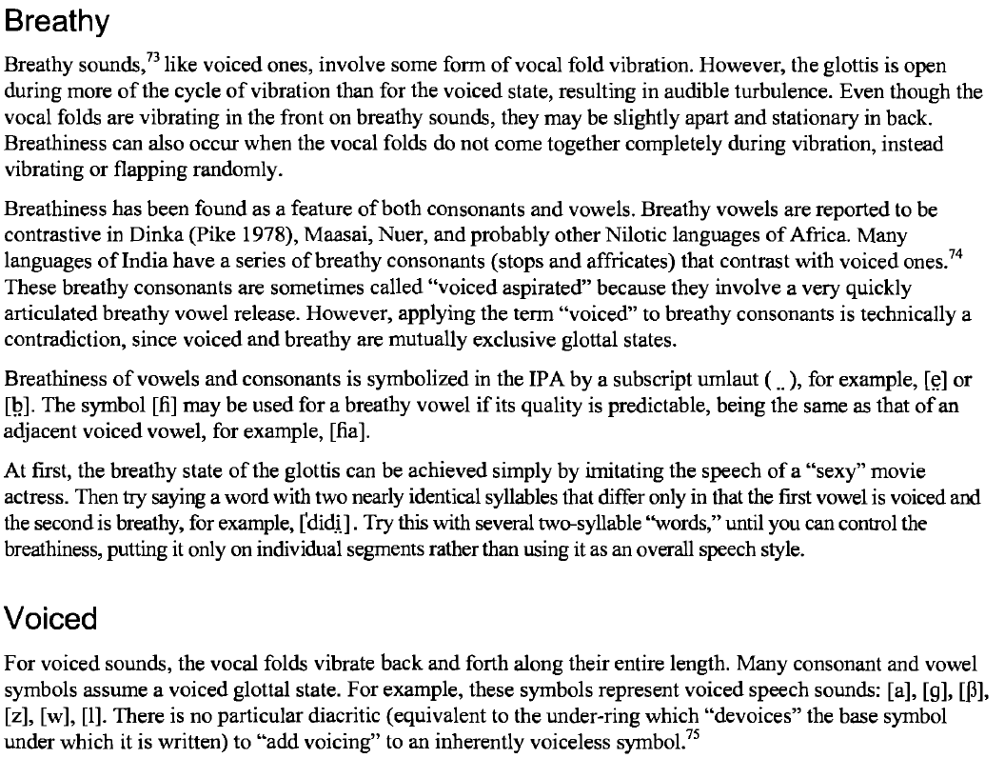

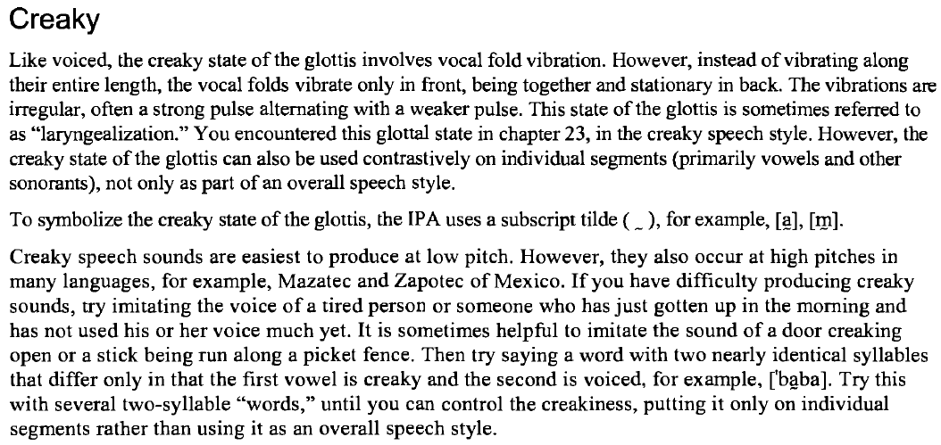

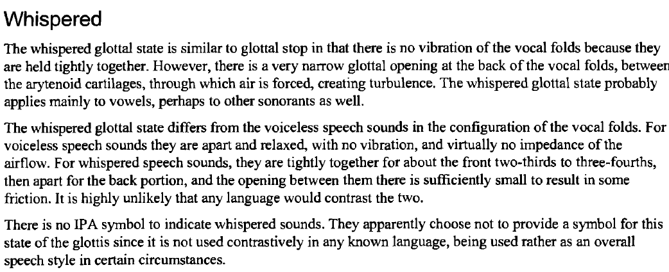

syllabic

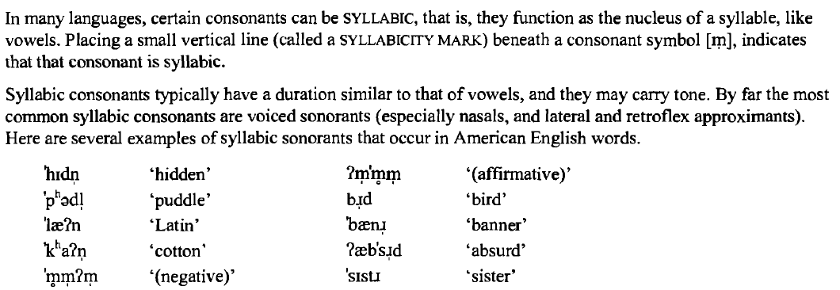

VOWELS

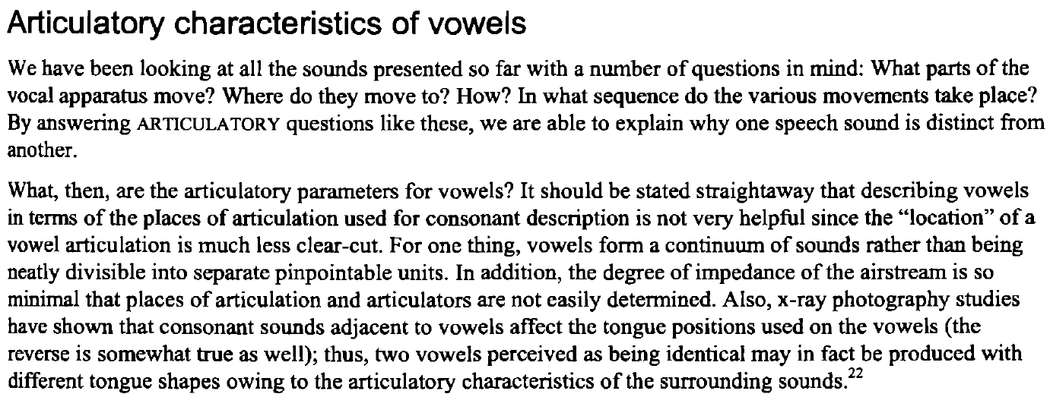

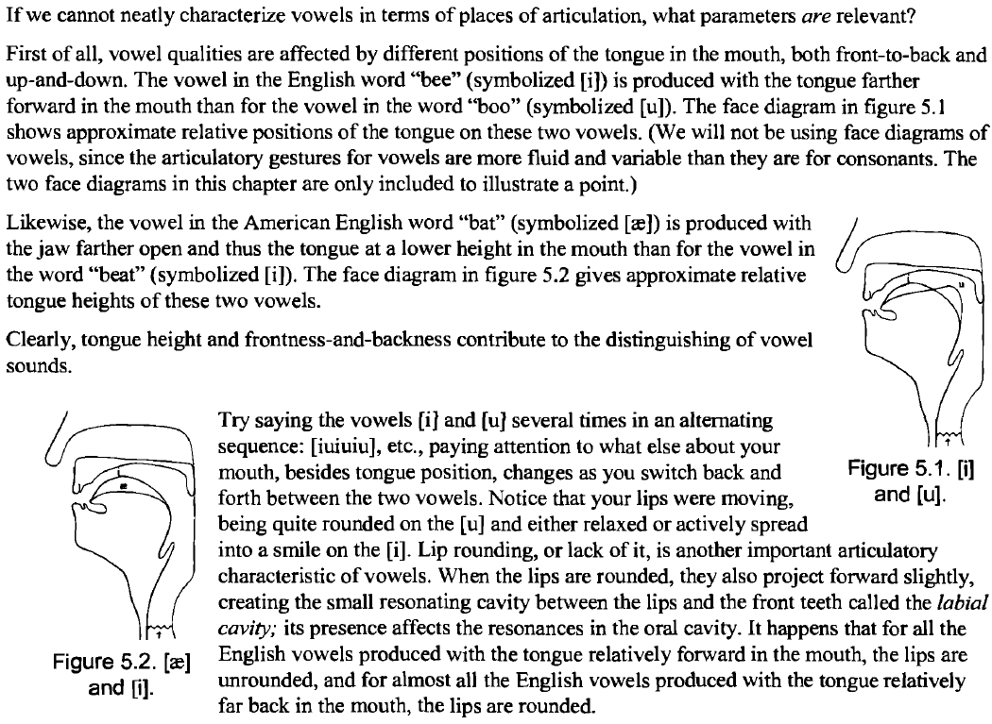

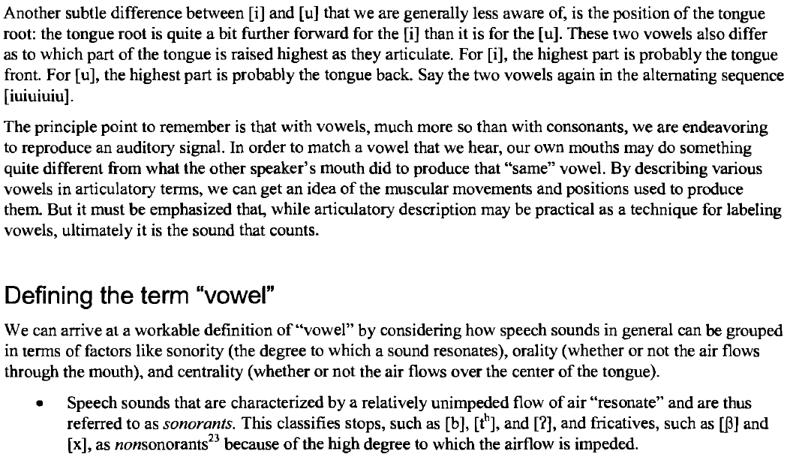

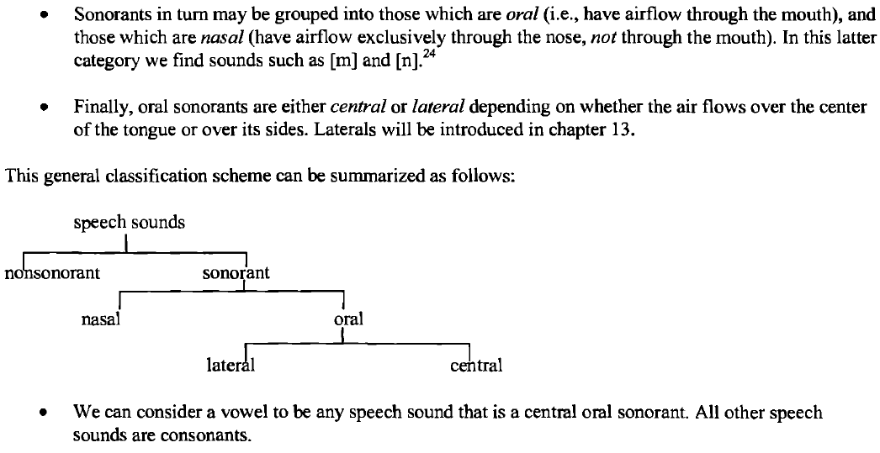

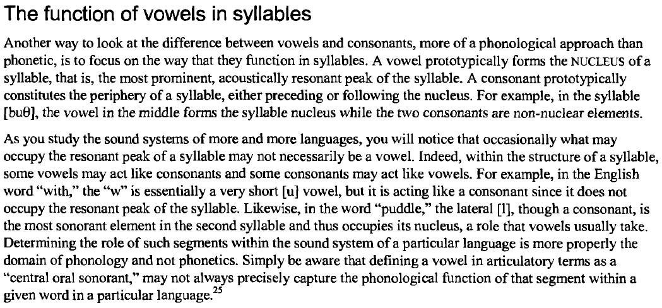

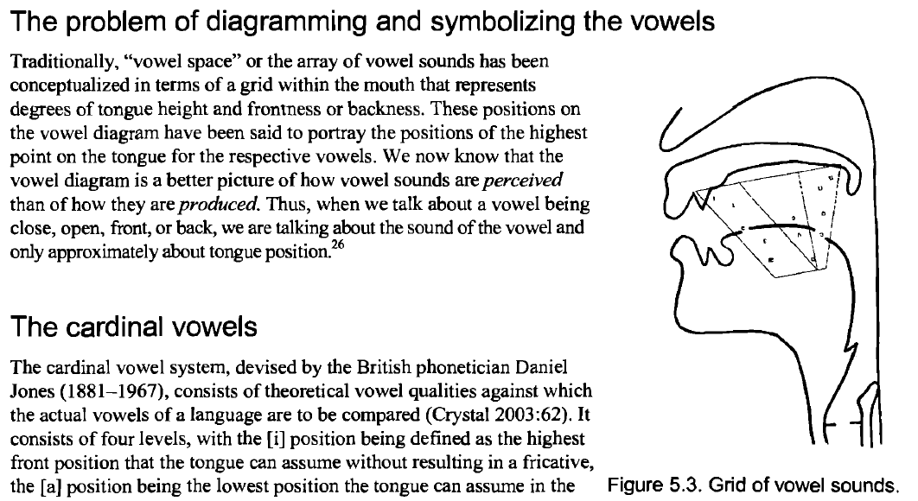

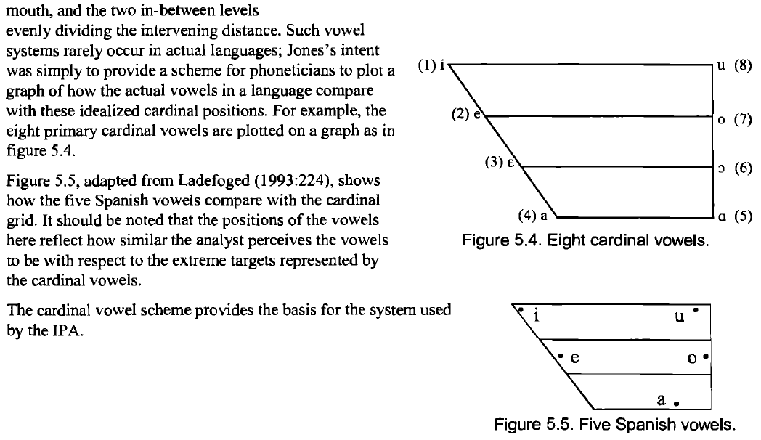

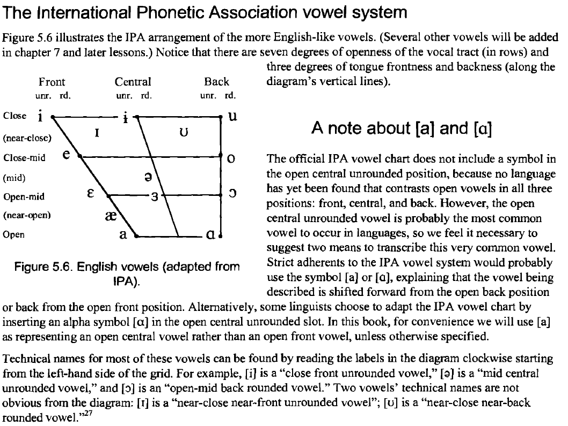



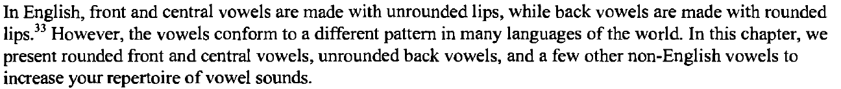

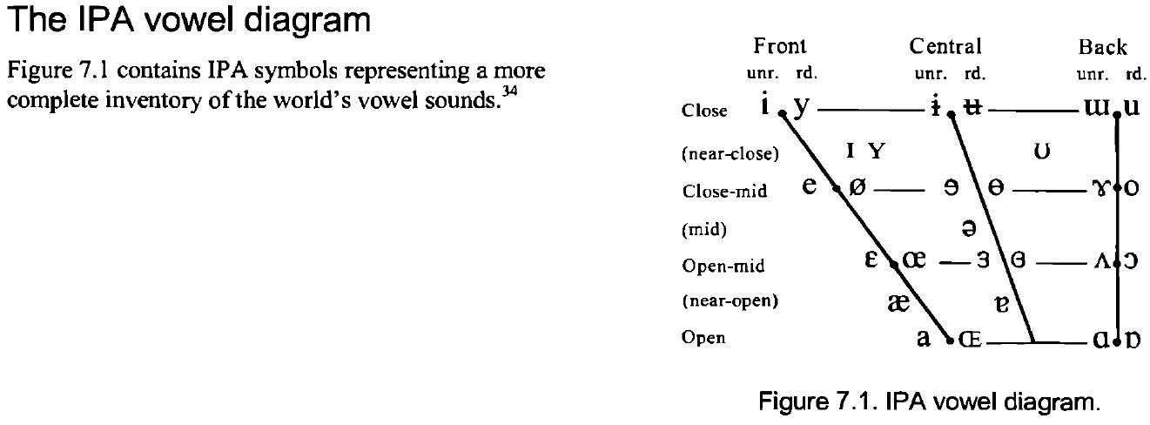

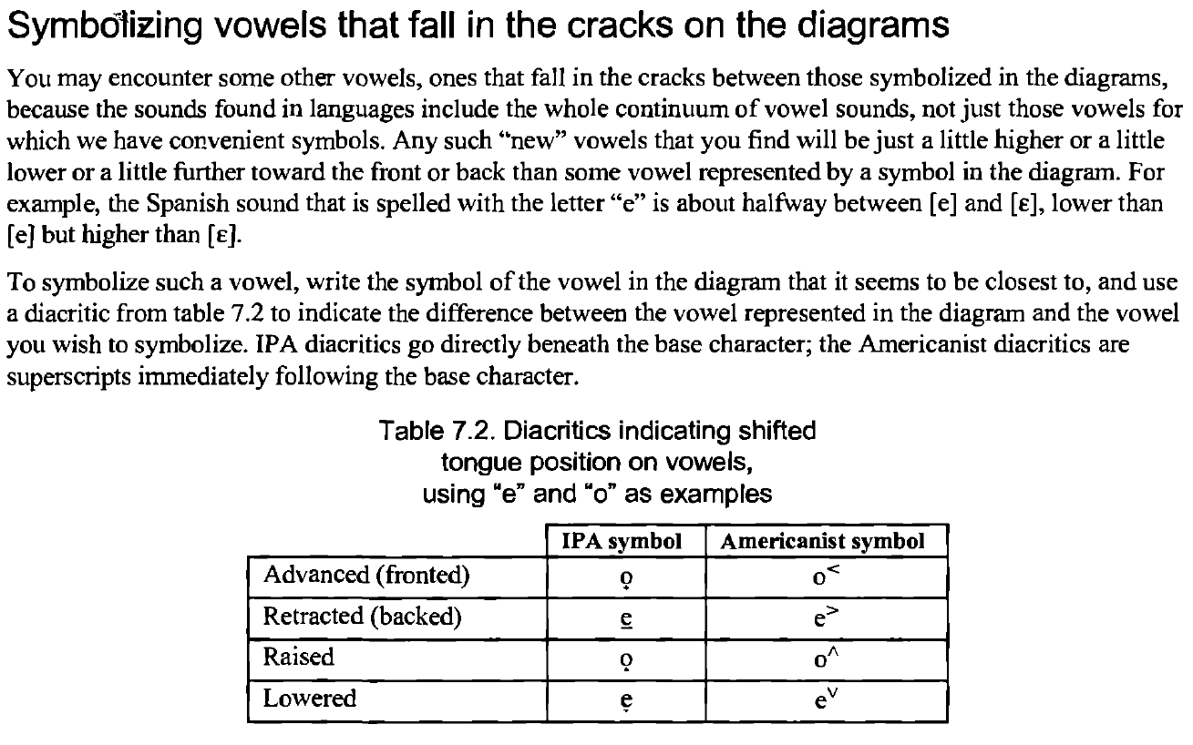

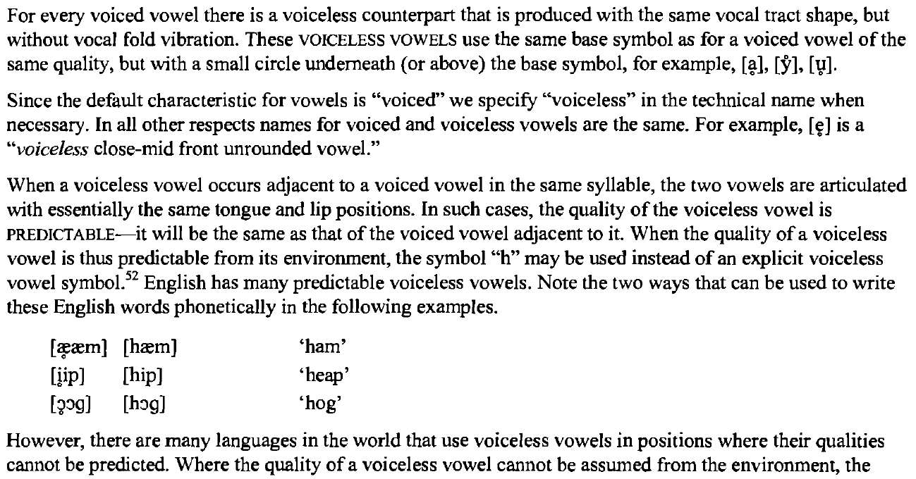

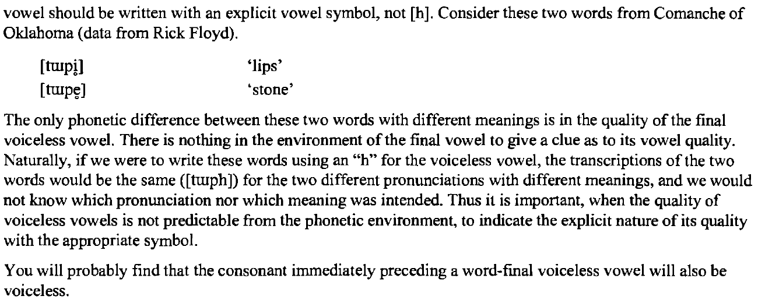

nasal

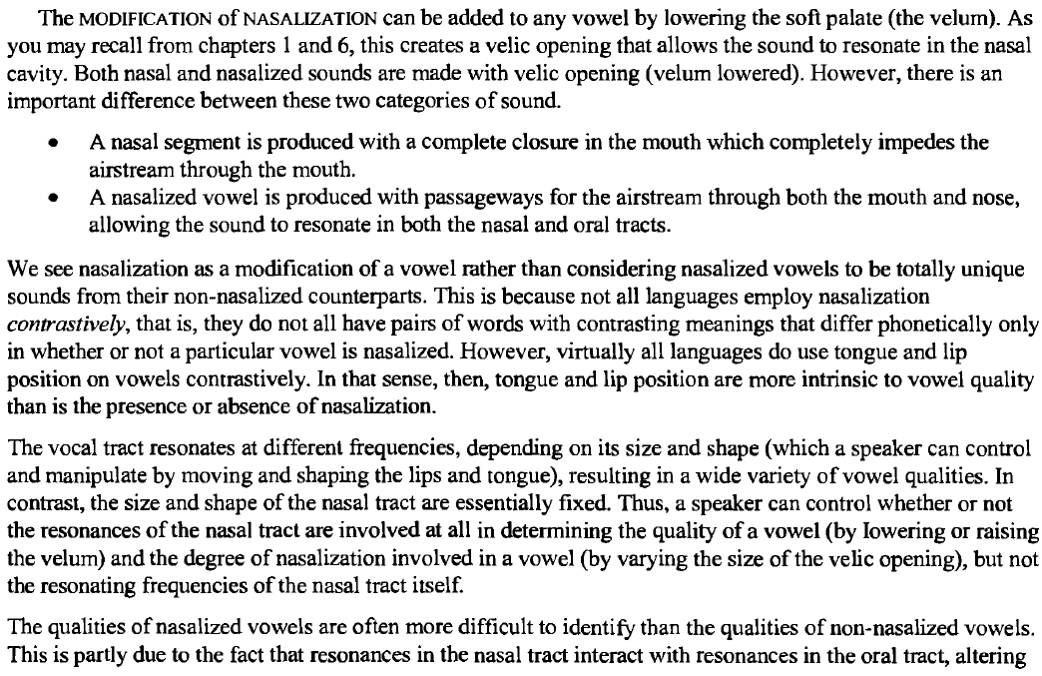

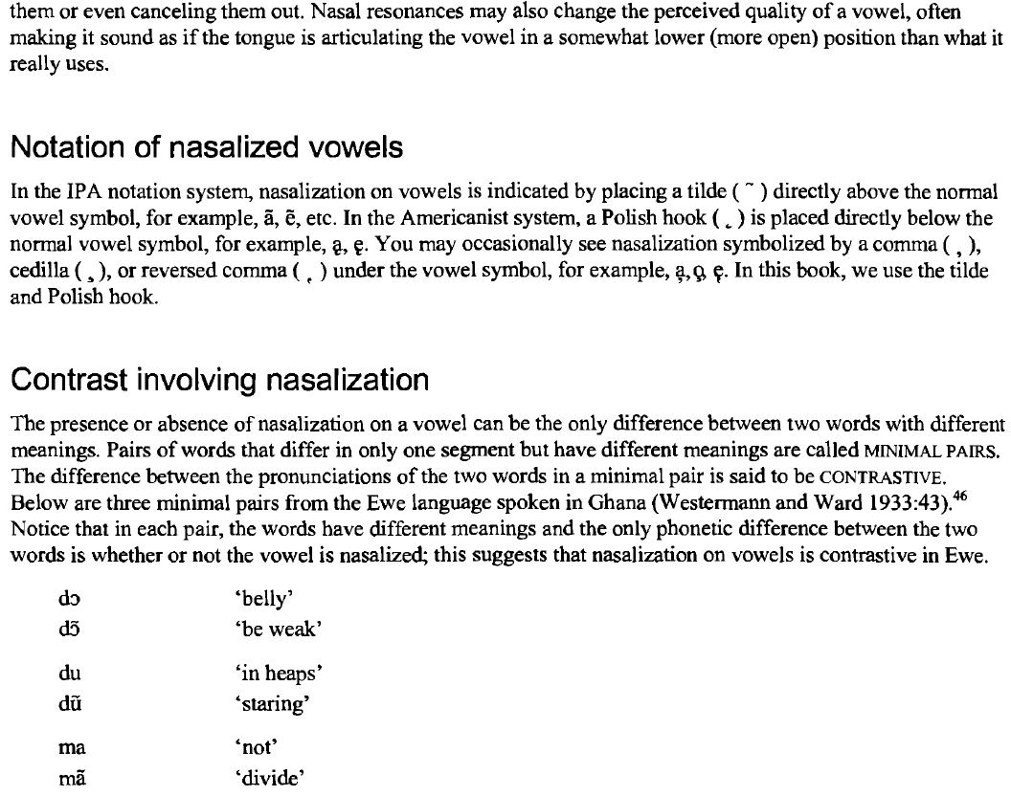

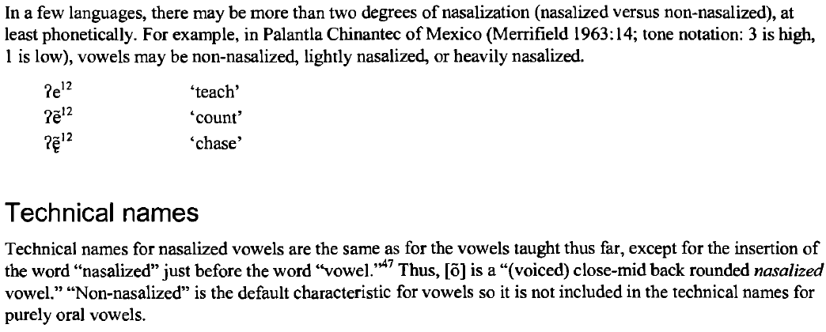

tongue root placement

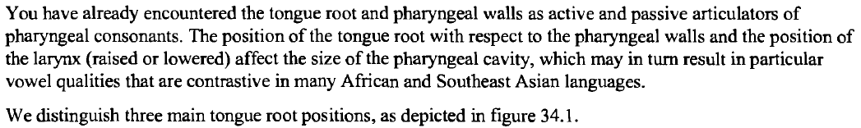

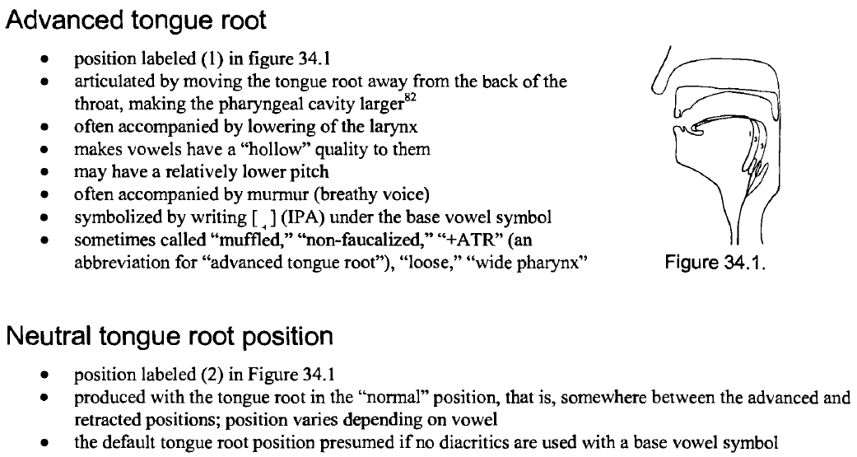

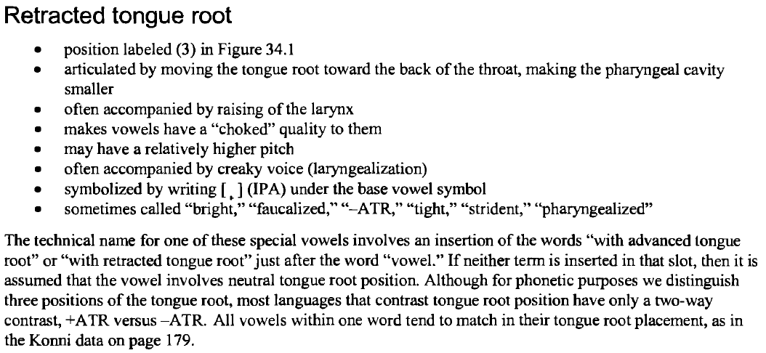

CLuster

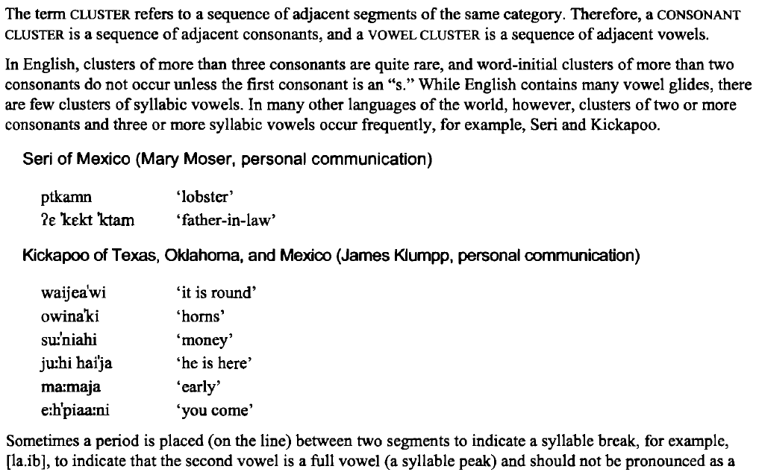

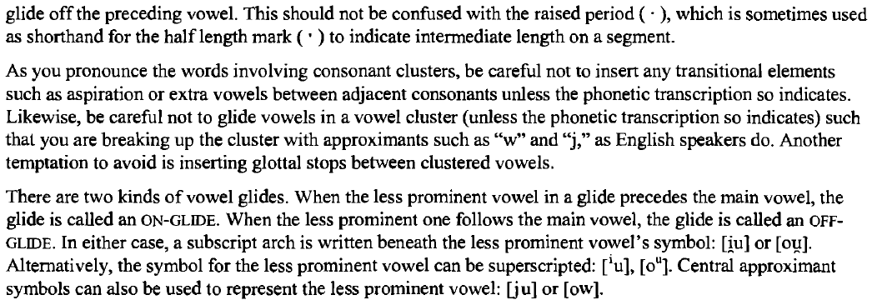

length

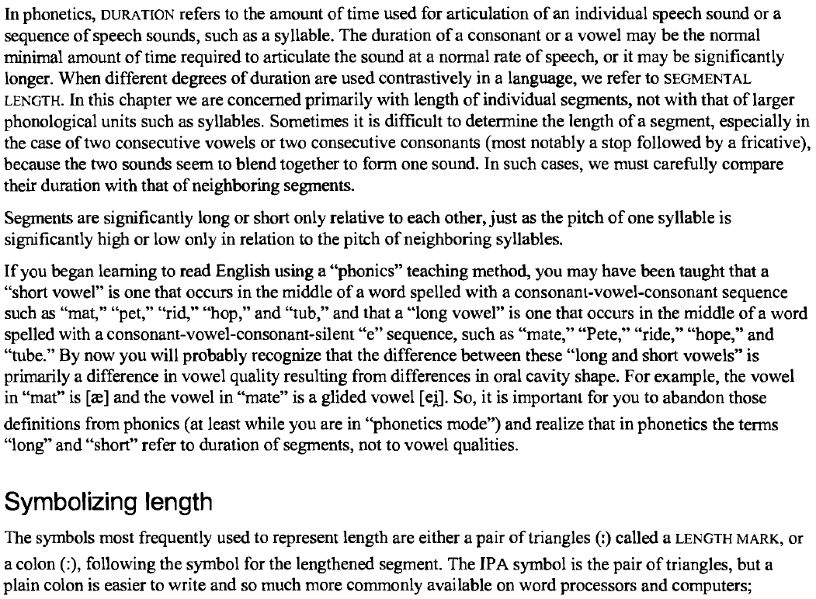

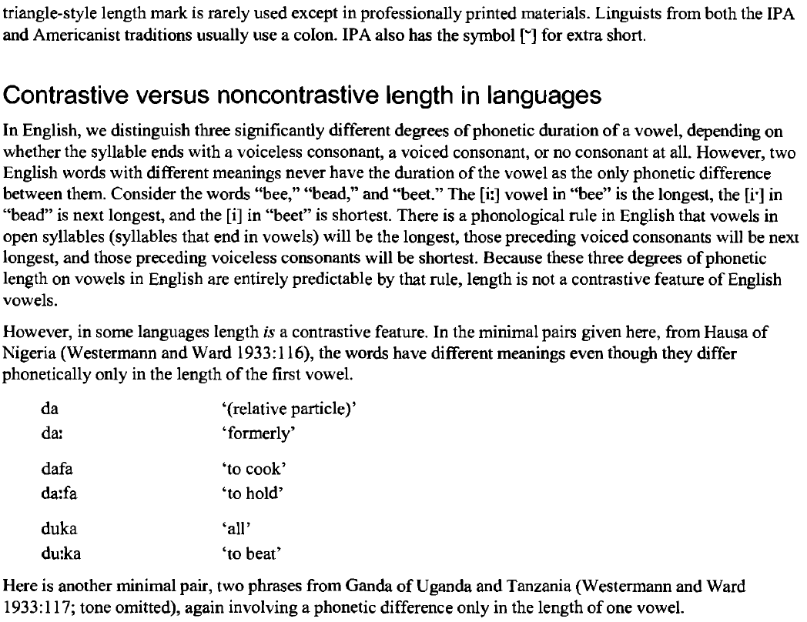

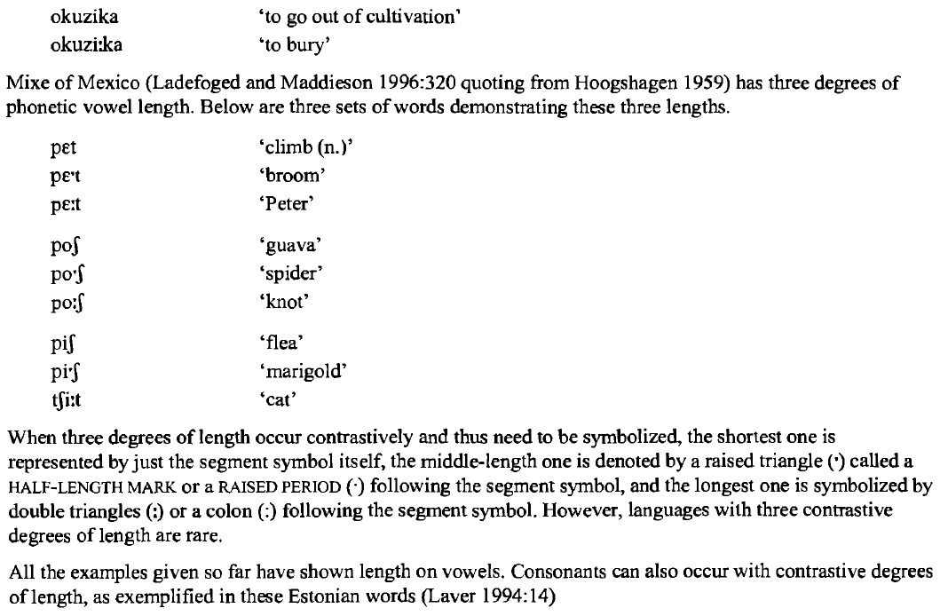

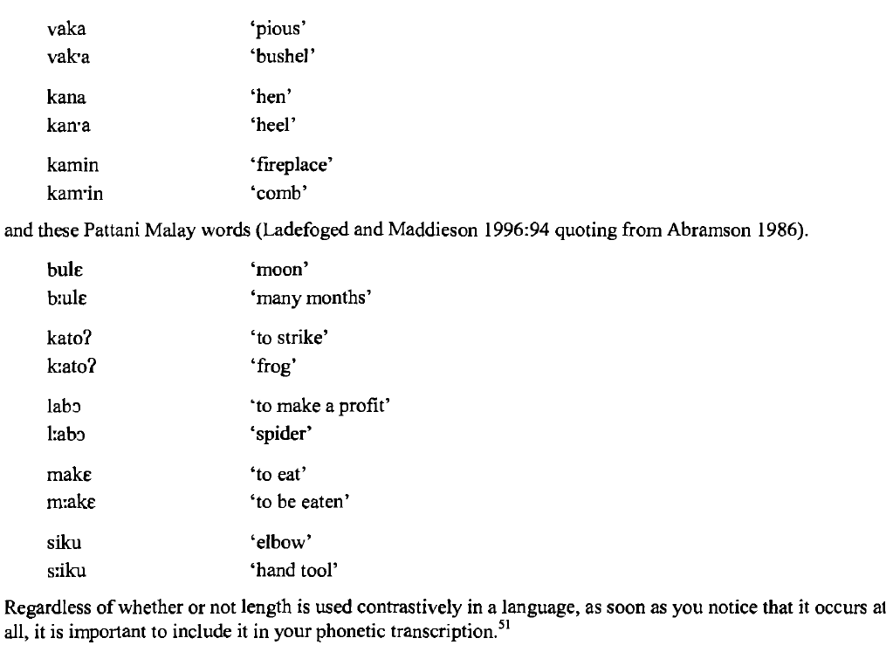

pitch i intonation

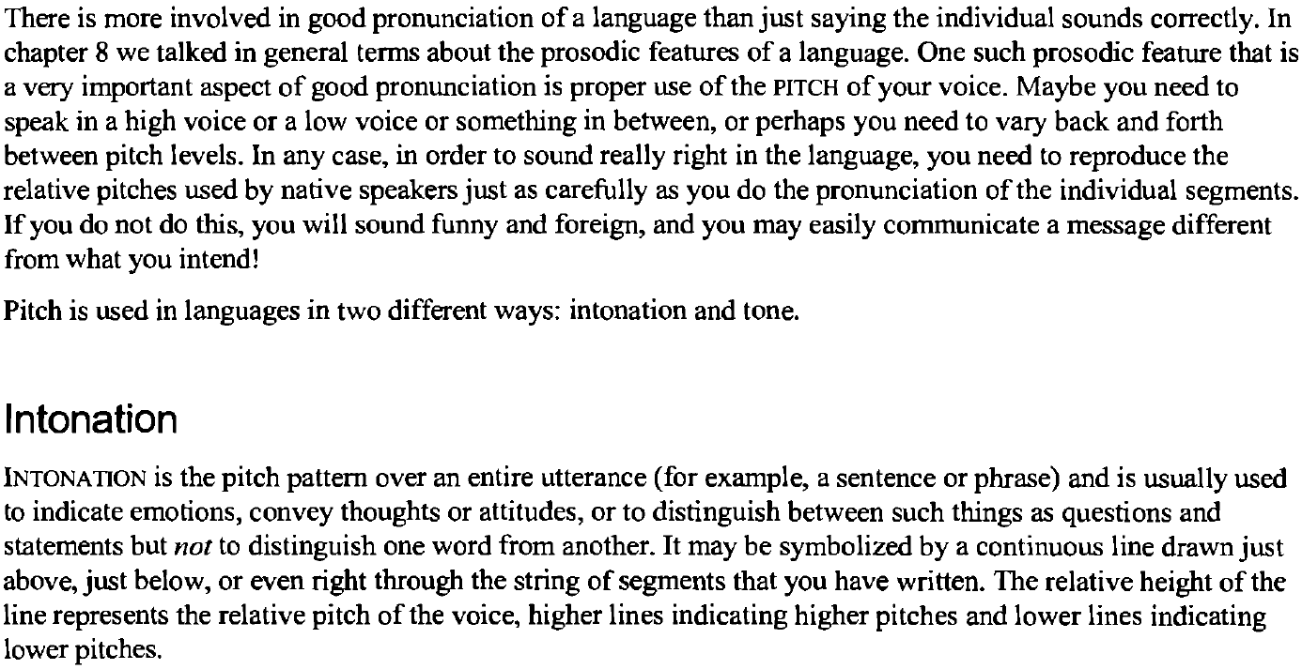

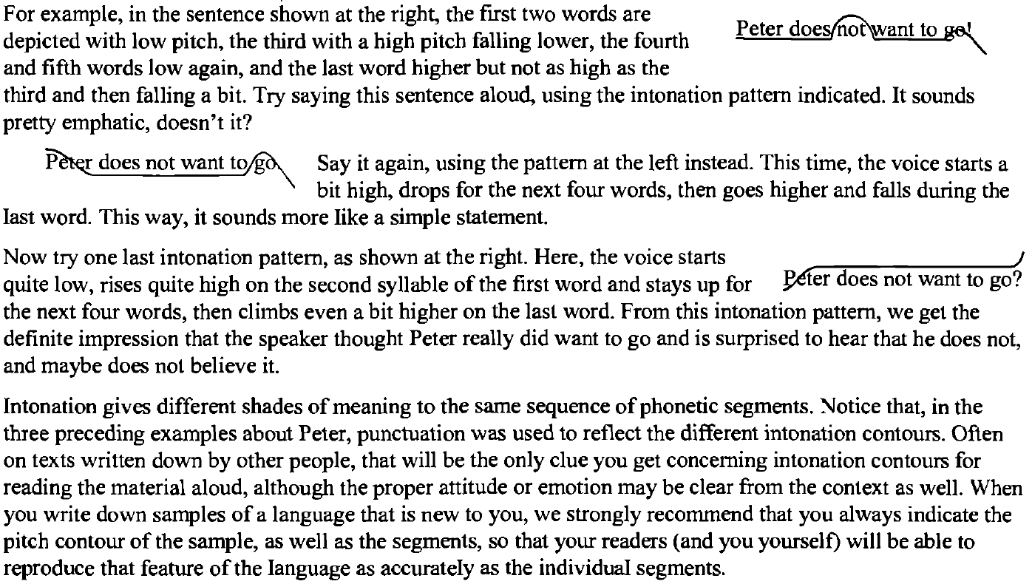

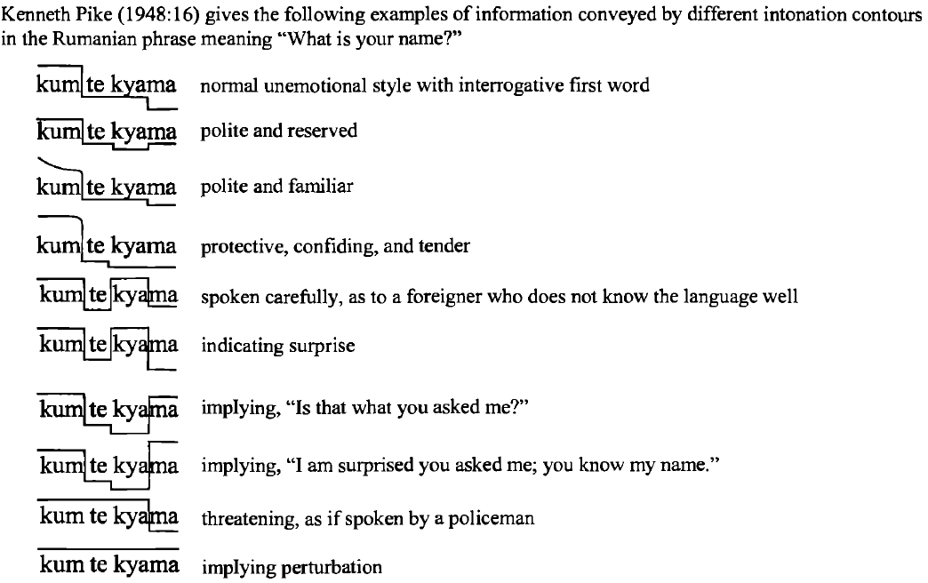

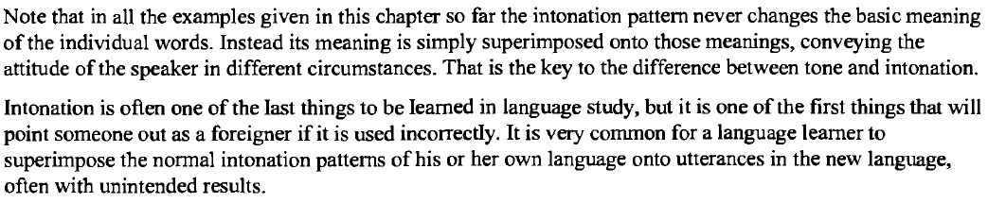

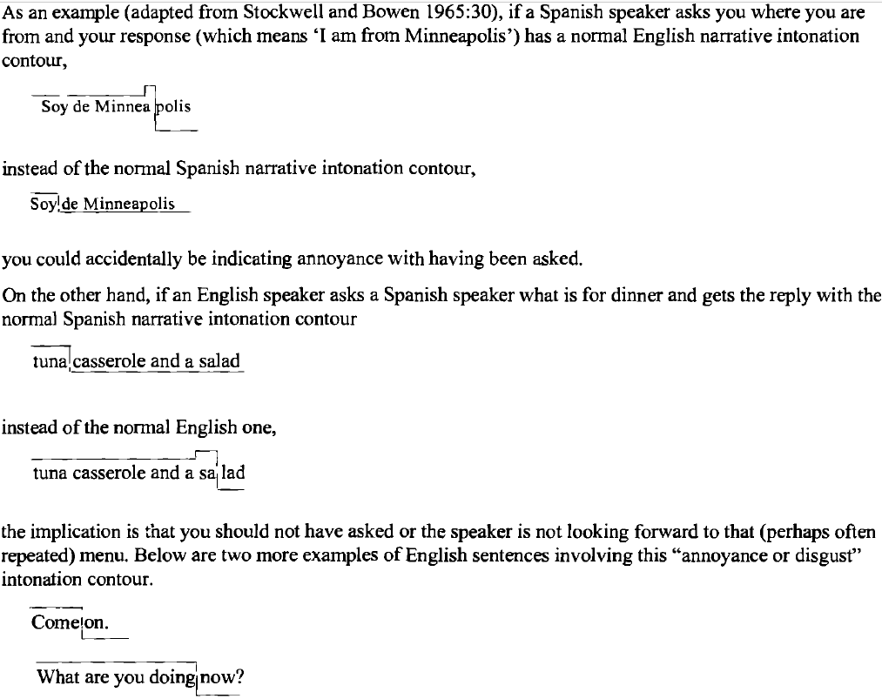

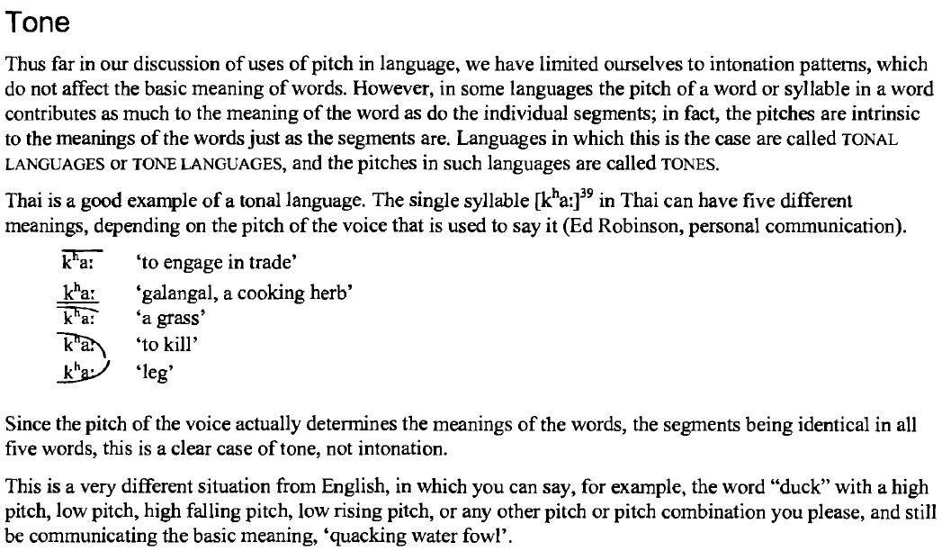

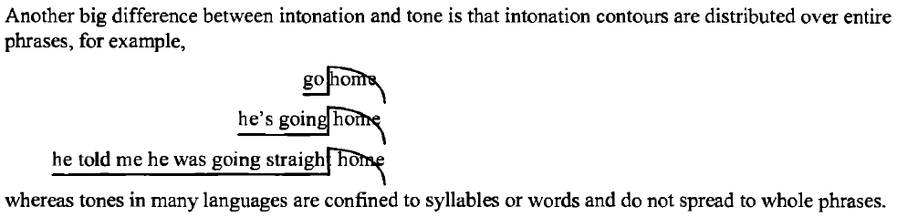

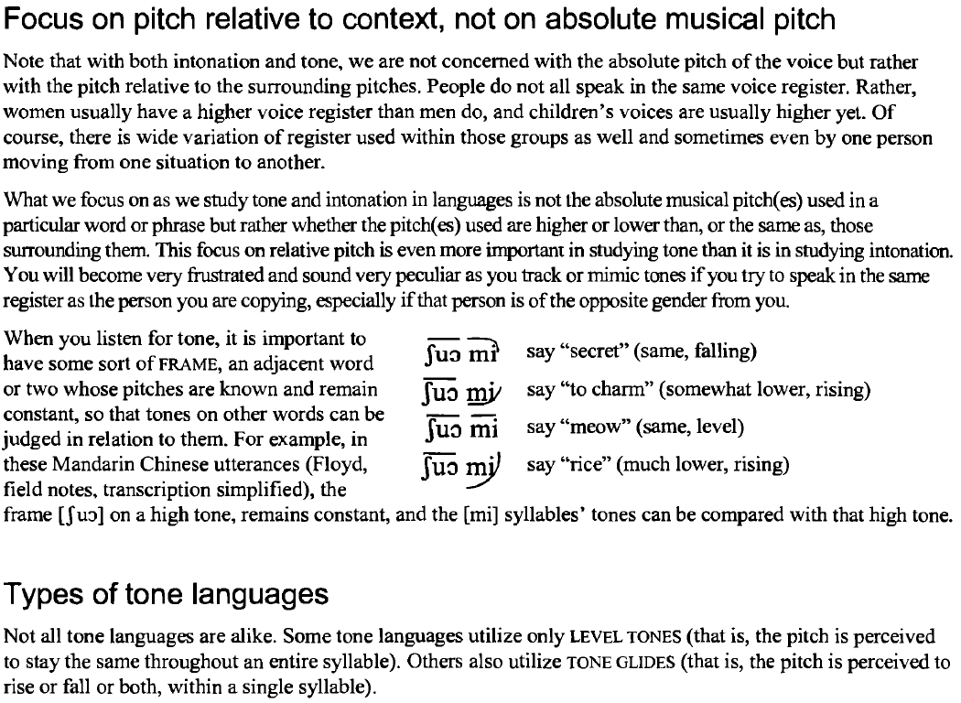

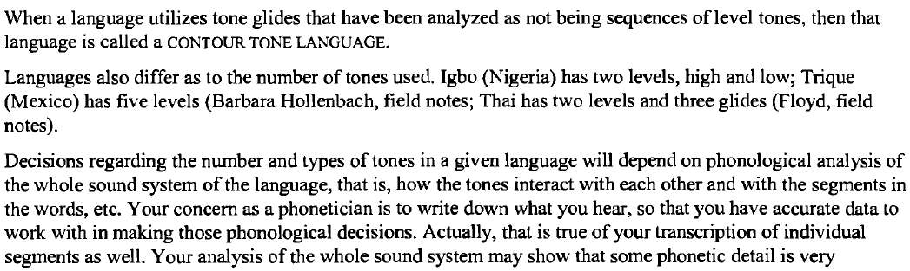

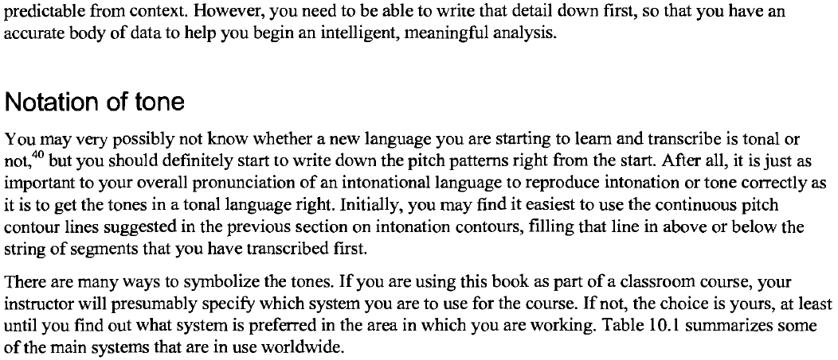

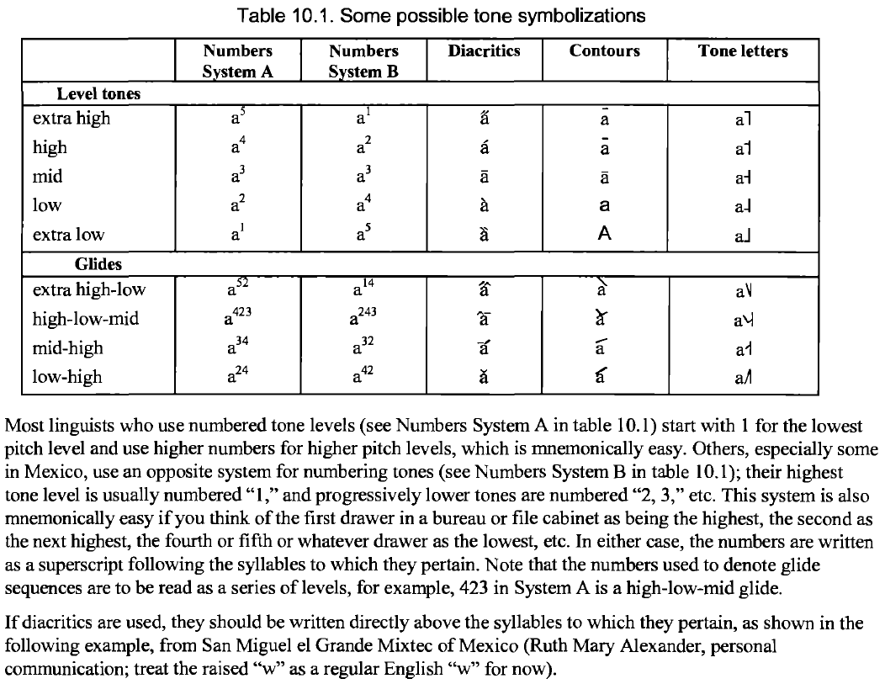

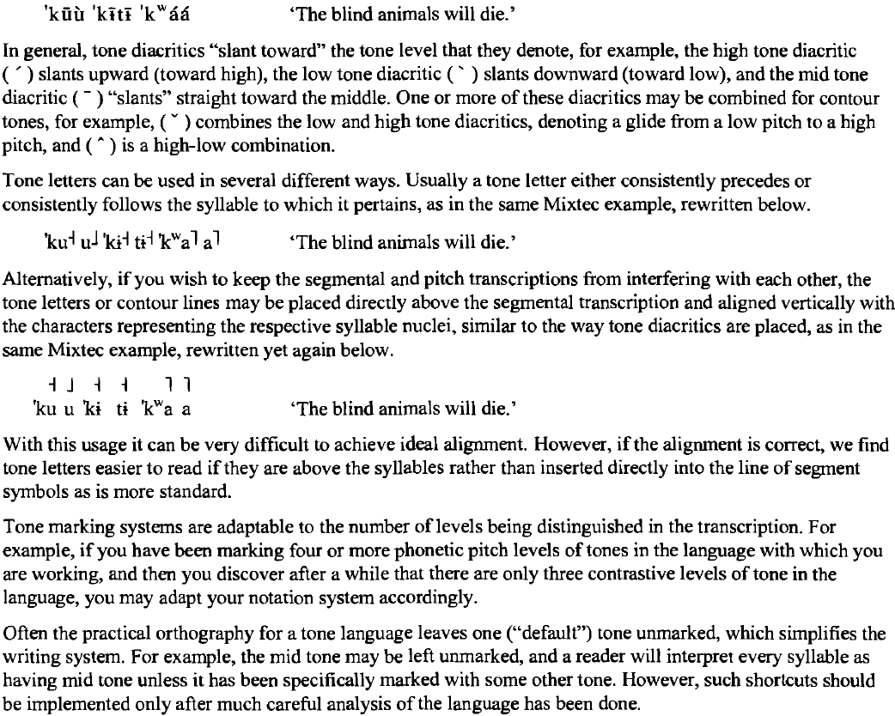

stress

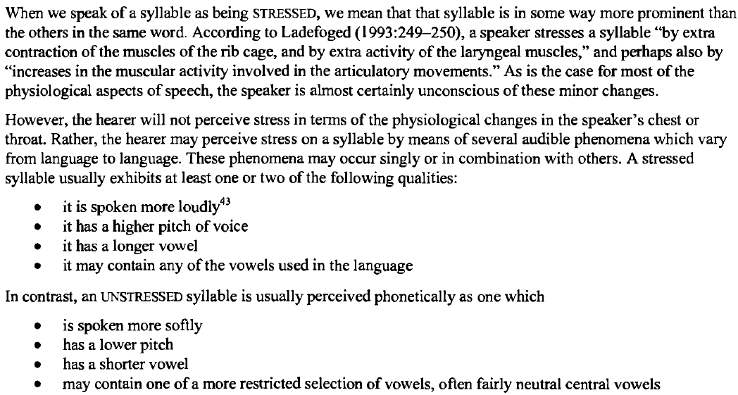

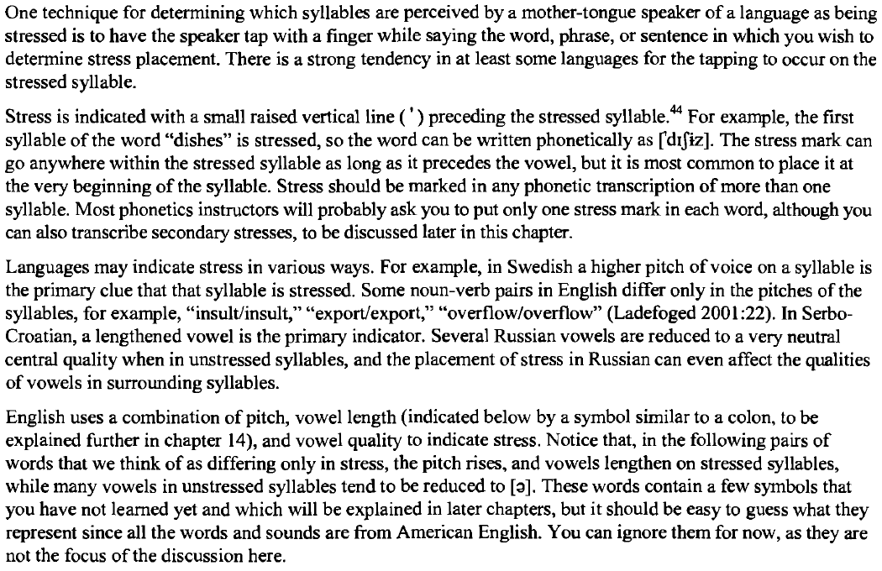

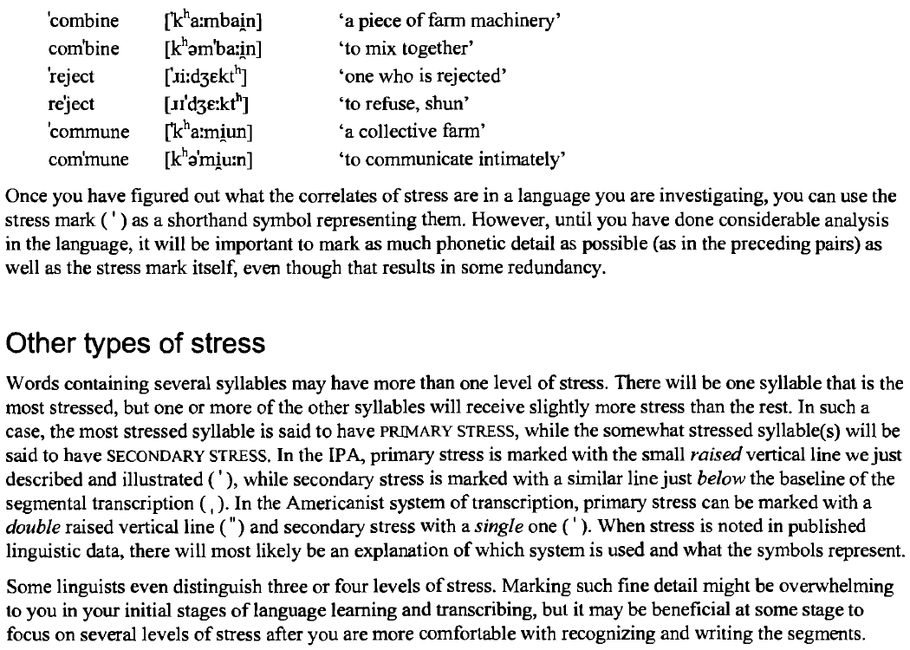

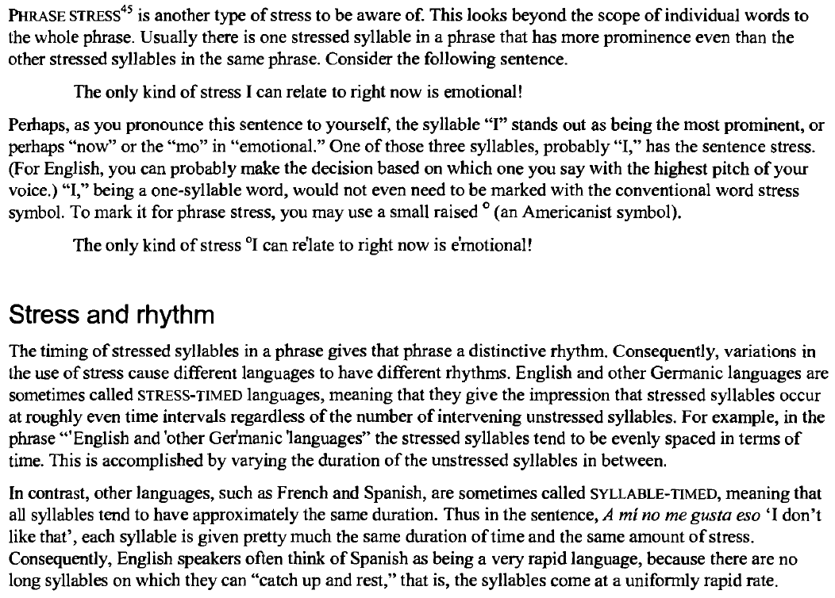

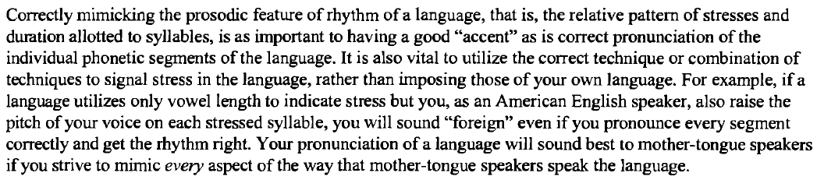

parts

Articulatory Phonetics

Consonants

Place

Manner

Secondary

Vowels

Primary

Secondary

Suprasegmentals